Project Mobile Application

App “Money Keeper”

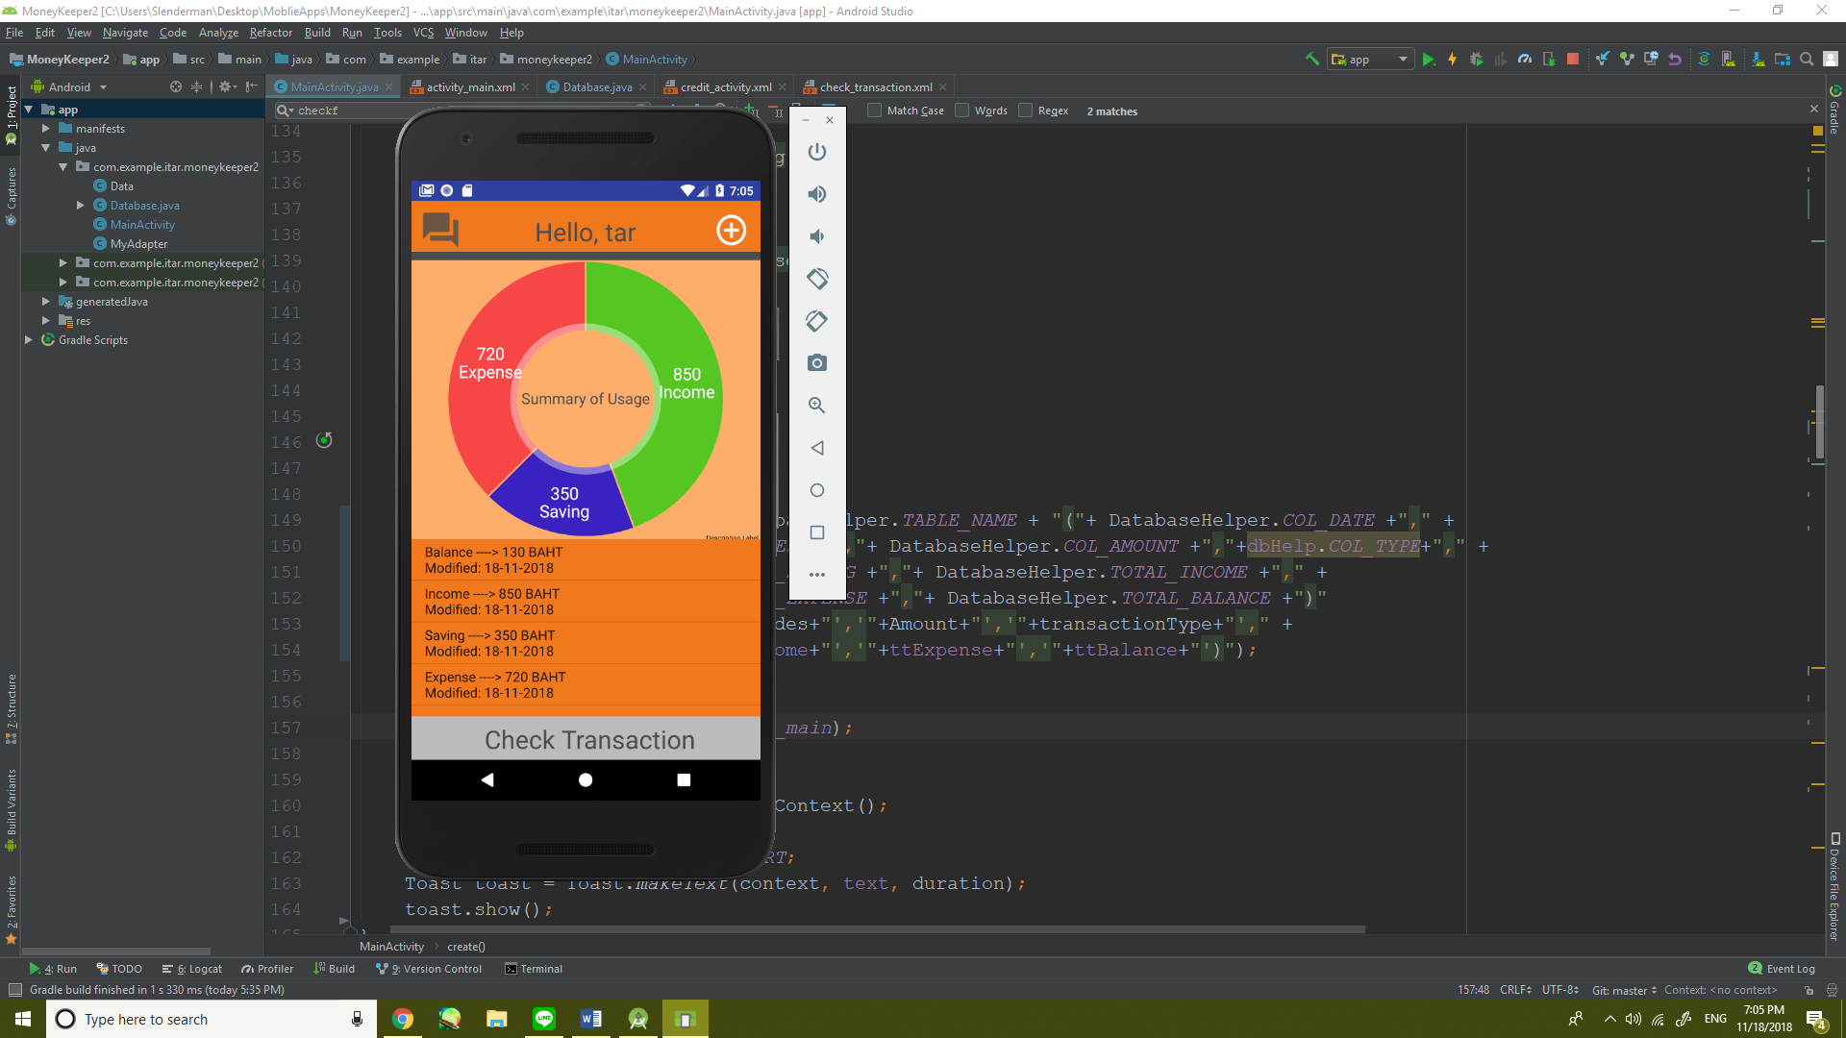

Contents Page

1.Function of Application 3

2.How to use Application 4

3.Project Structure-Flowchart 8

4.Project Structure-UML 9

5.Code 10

6.Gradle 16

7.All XML Files 17

8. Bibliography 24

Prepared by

1.5904062660191 Mr.NOPPAWEE DEEJUNGWIPHAT

2.5904062663123 Mr.PANNAWAT NIYOMRAT

Function of Application

-Money Keeper this Application use for about save money in everyday life.

-Note title about income, expense and saving

How to use Application

-In the first page, there is a Hello page, you can slide left and you will see ‘Next’ button. When you click on it, it will lead you to registration page.

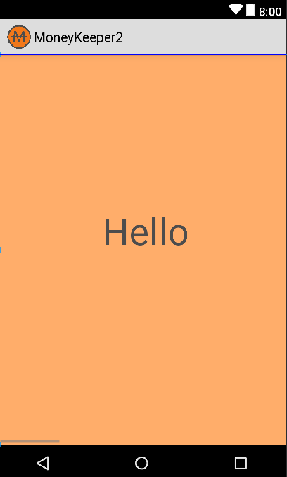

-Registration page ,there have fill box name and money. You have to enter your nickname and your first money for initialize balance so, after that press next

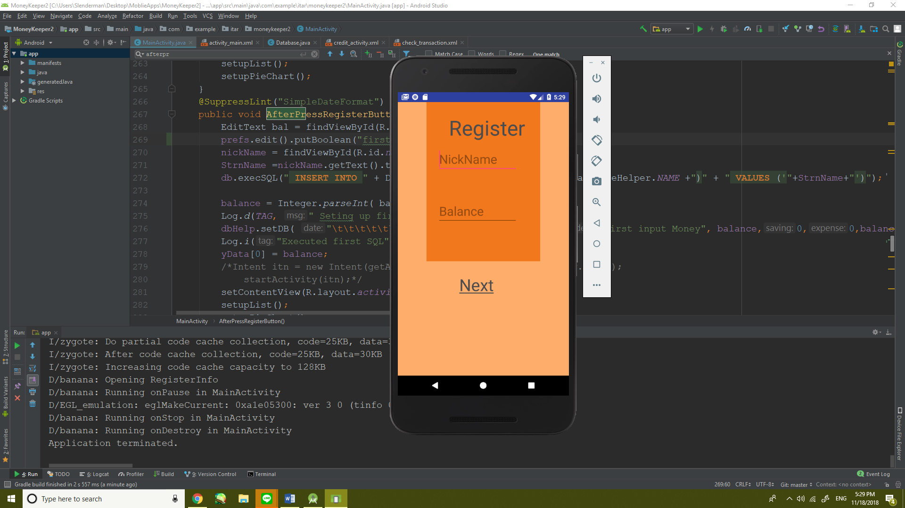

-After fill information finish, press Next. It will lead you to Main page.

In ListView on Main Page, it’ll show :

1.Balance from total summarize data of Income – Expense.

2.Income from total summarize data of Income in DATABASE.

3.Saving from total summarize data of Saving in DATABASE.

4.Expense from total summarize data of Expense in DATABASE.

-When you on Main page, click on button ‘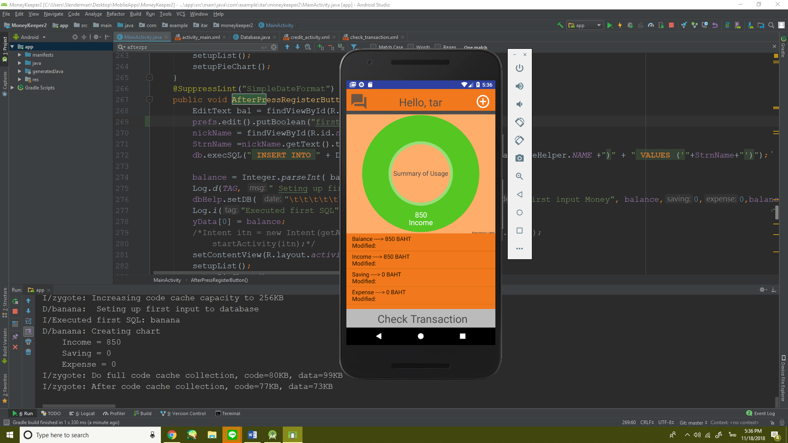’. It will lead you to add new transaction page.



-When you’re on Add new transaction page. You have to select type of your new transaction by press the button. Next, input your description and amount after finish you choose create.

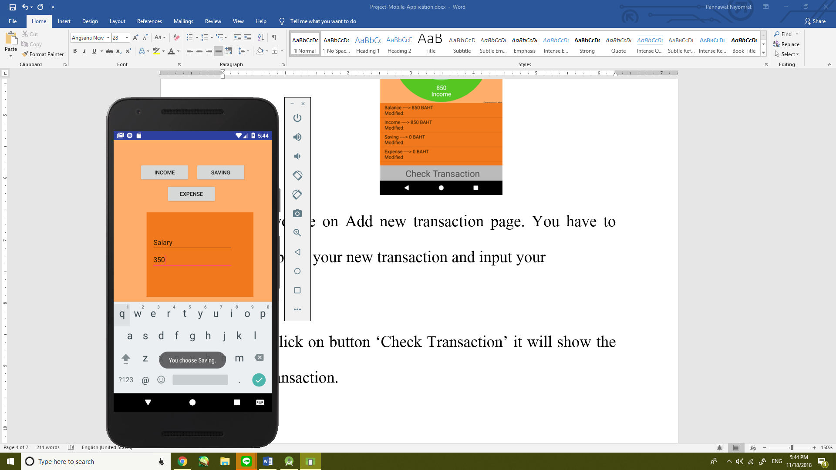

-When after you press create button, The new transaction will be added to Main page and stored in database by using SQLite.

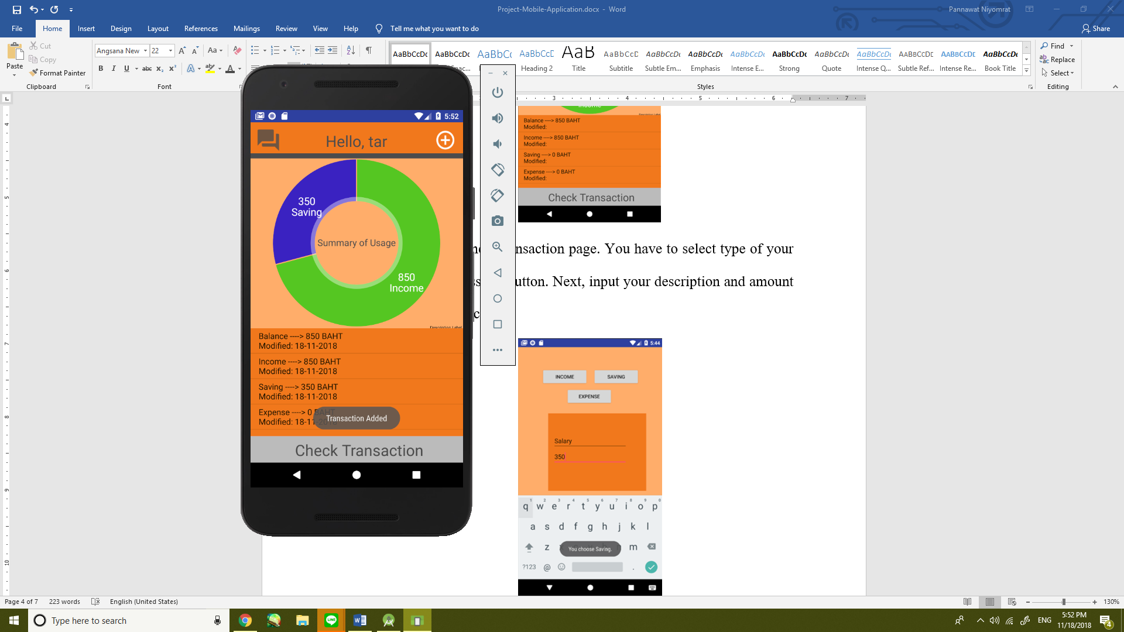

-When click on button ‘Check Transaction’ it will show the list of transaction.

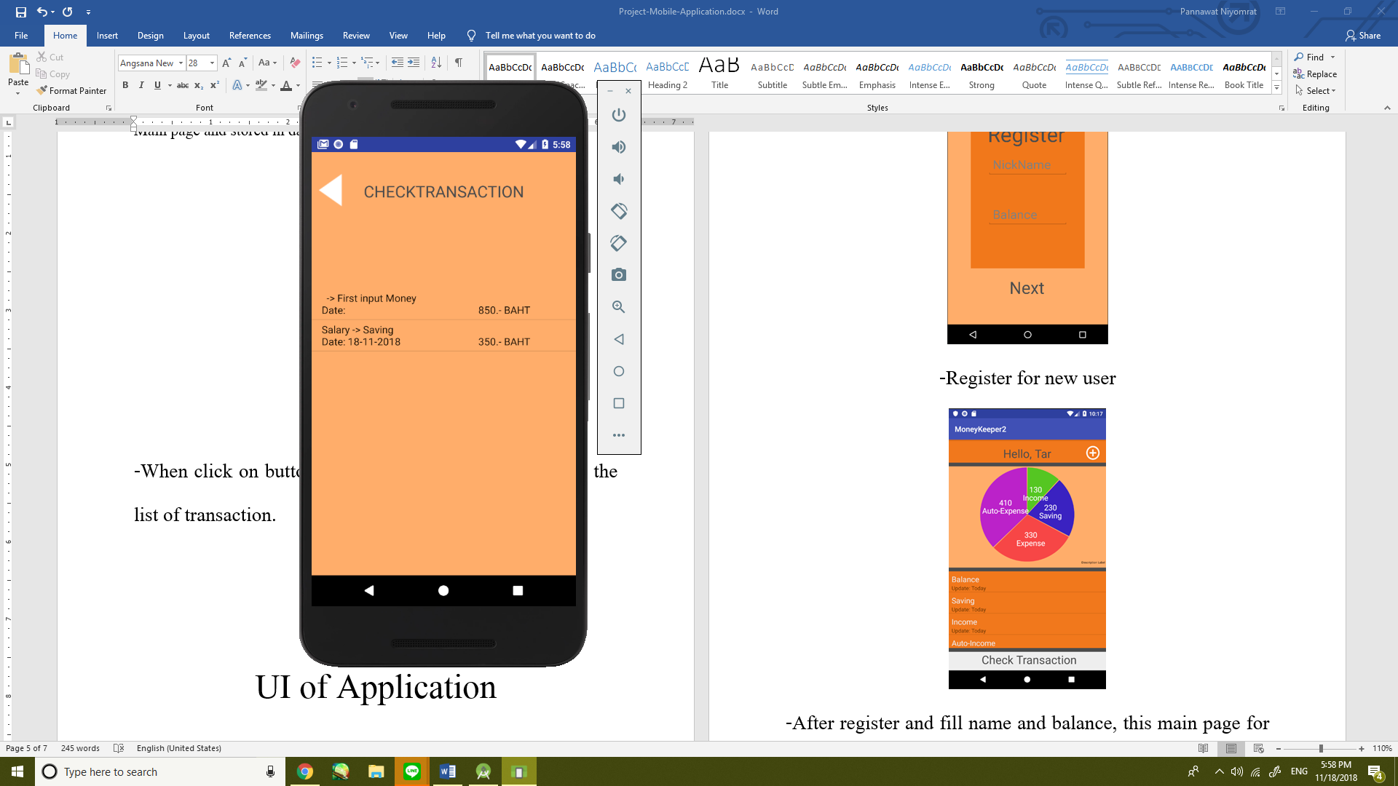

-After you’ve checked transactions Press “  ” to go back to Main Screen.

-In the Main Screen It’s also had the “  ” Button. It’s the button that lead you to credit page to say thank you.

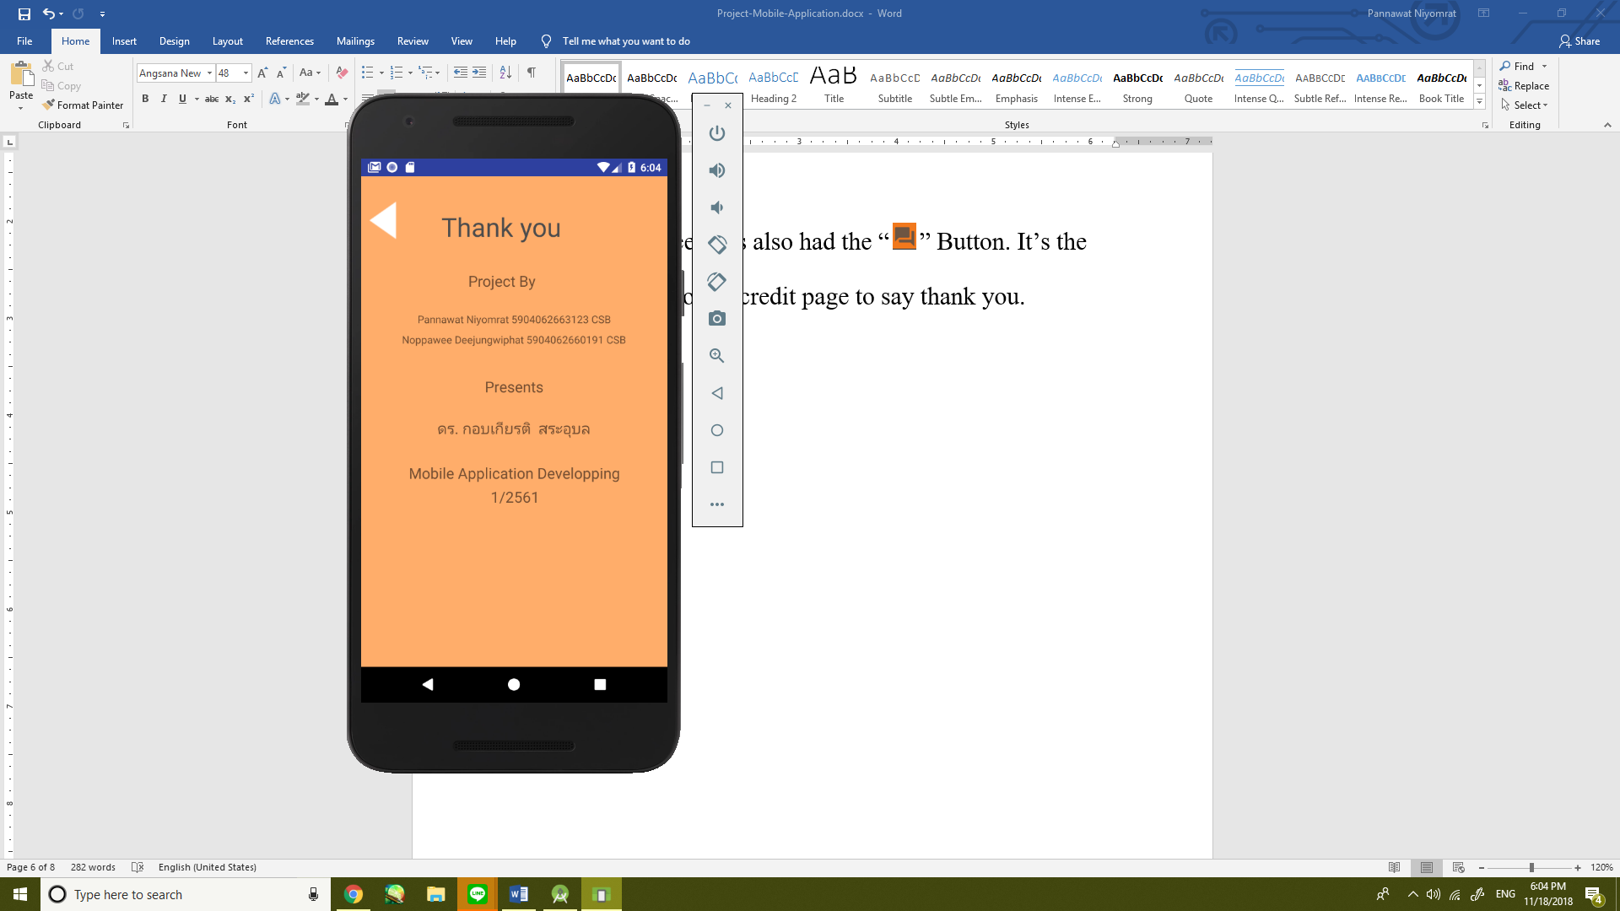

Project Structure of Application

Flowcharts

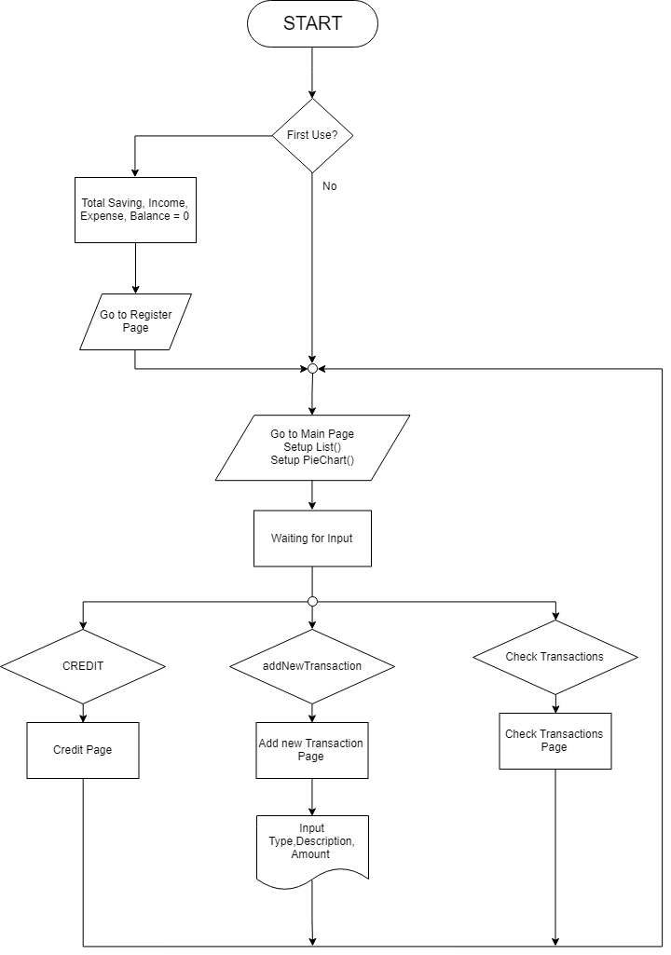

UML 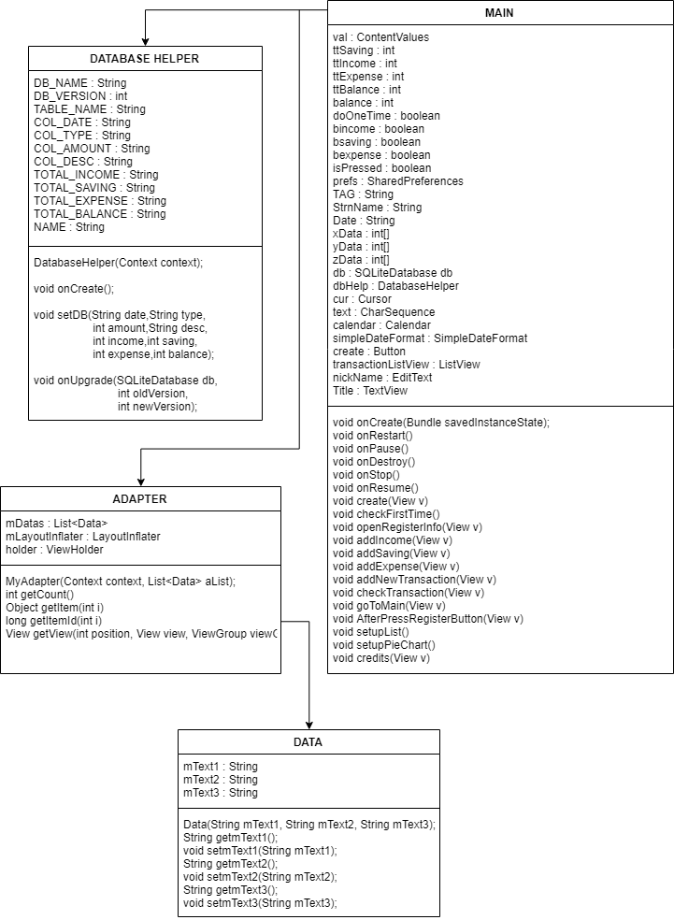

CODE

1. Check First Time Using Application.

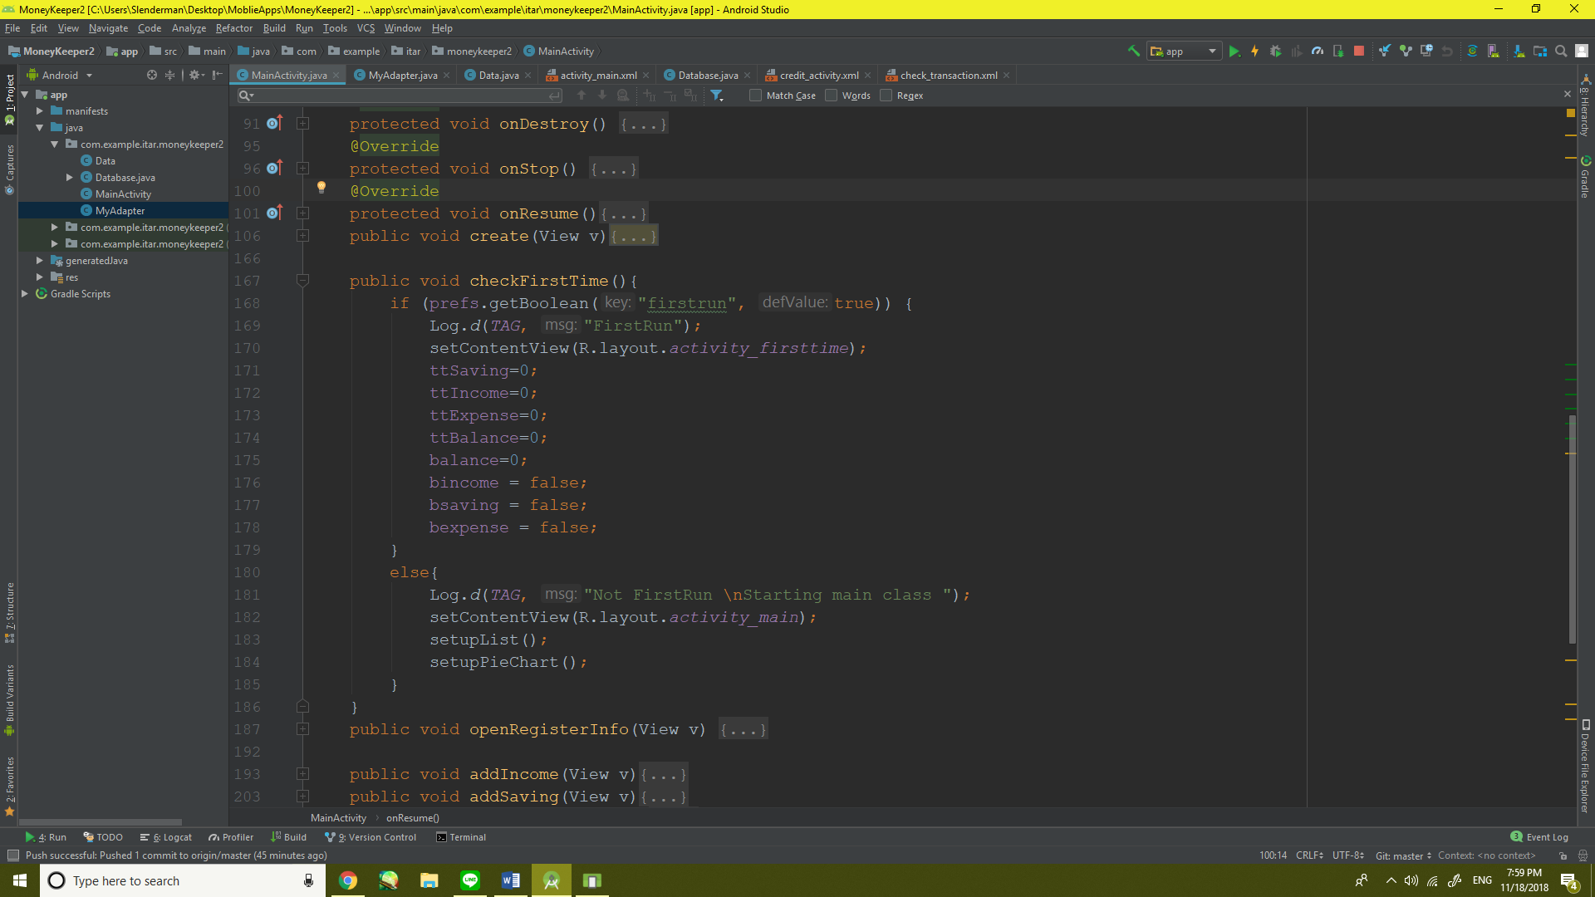

2.Register for First Use

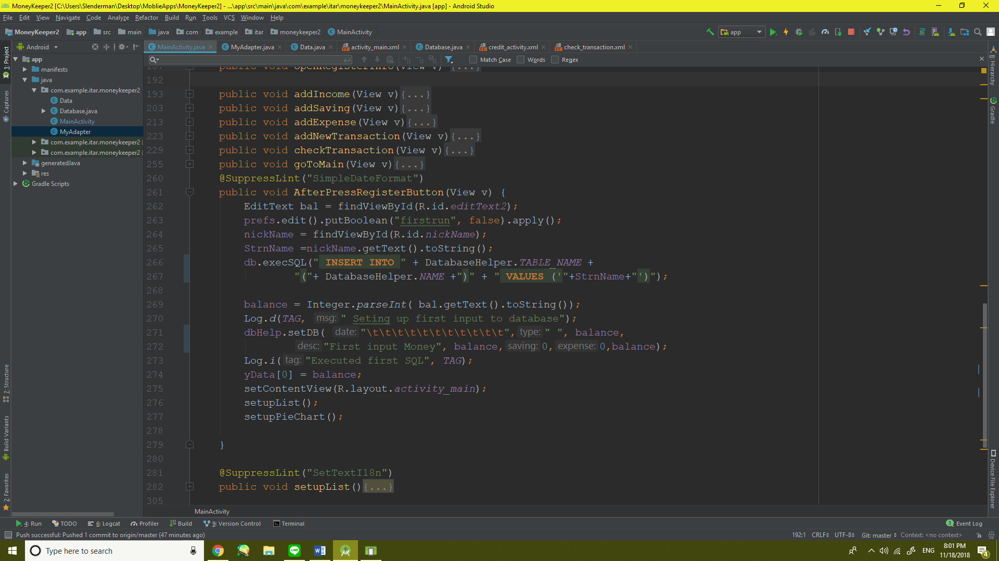

3.Set up List/Pie Chart

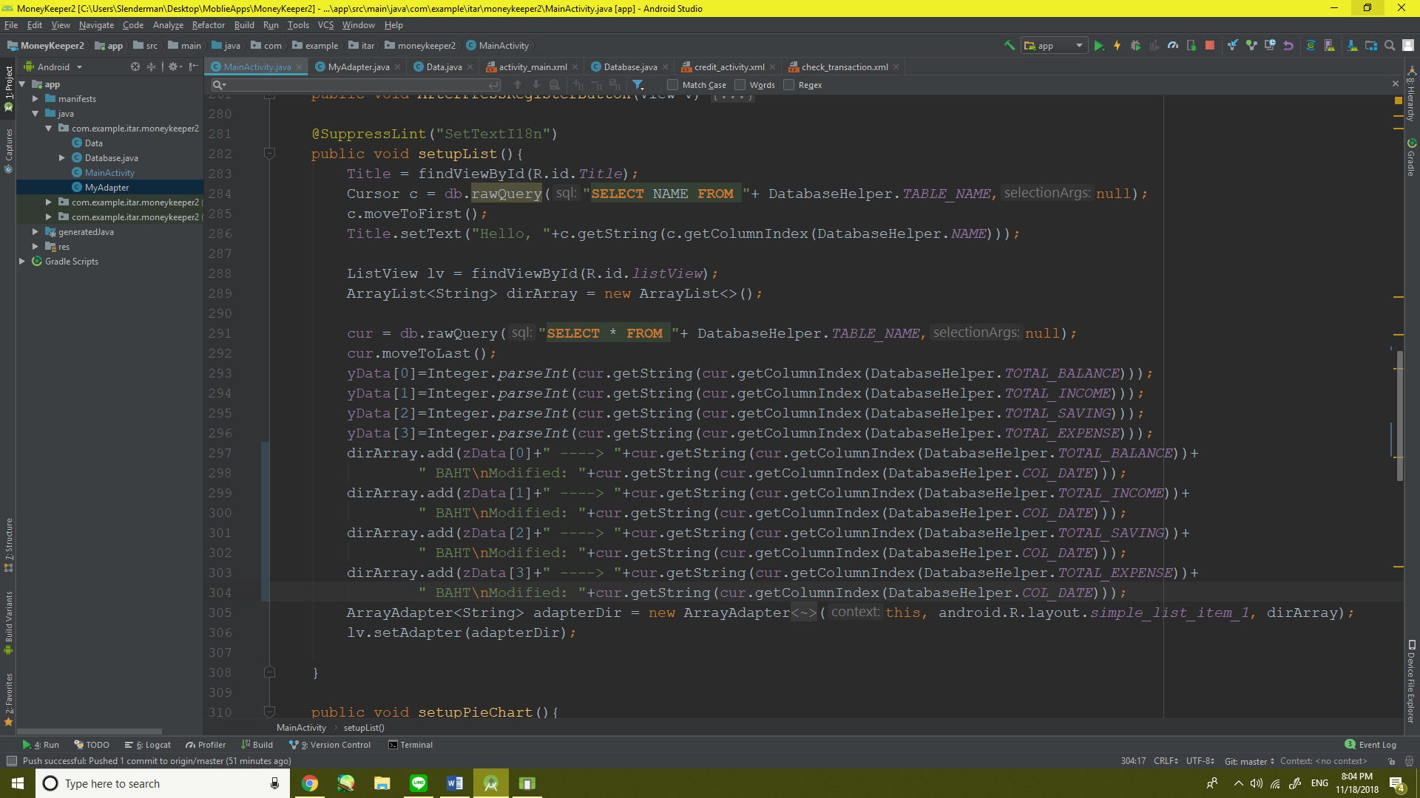

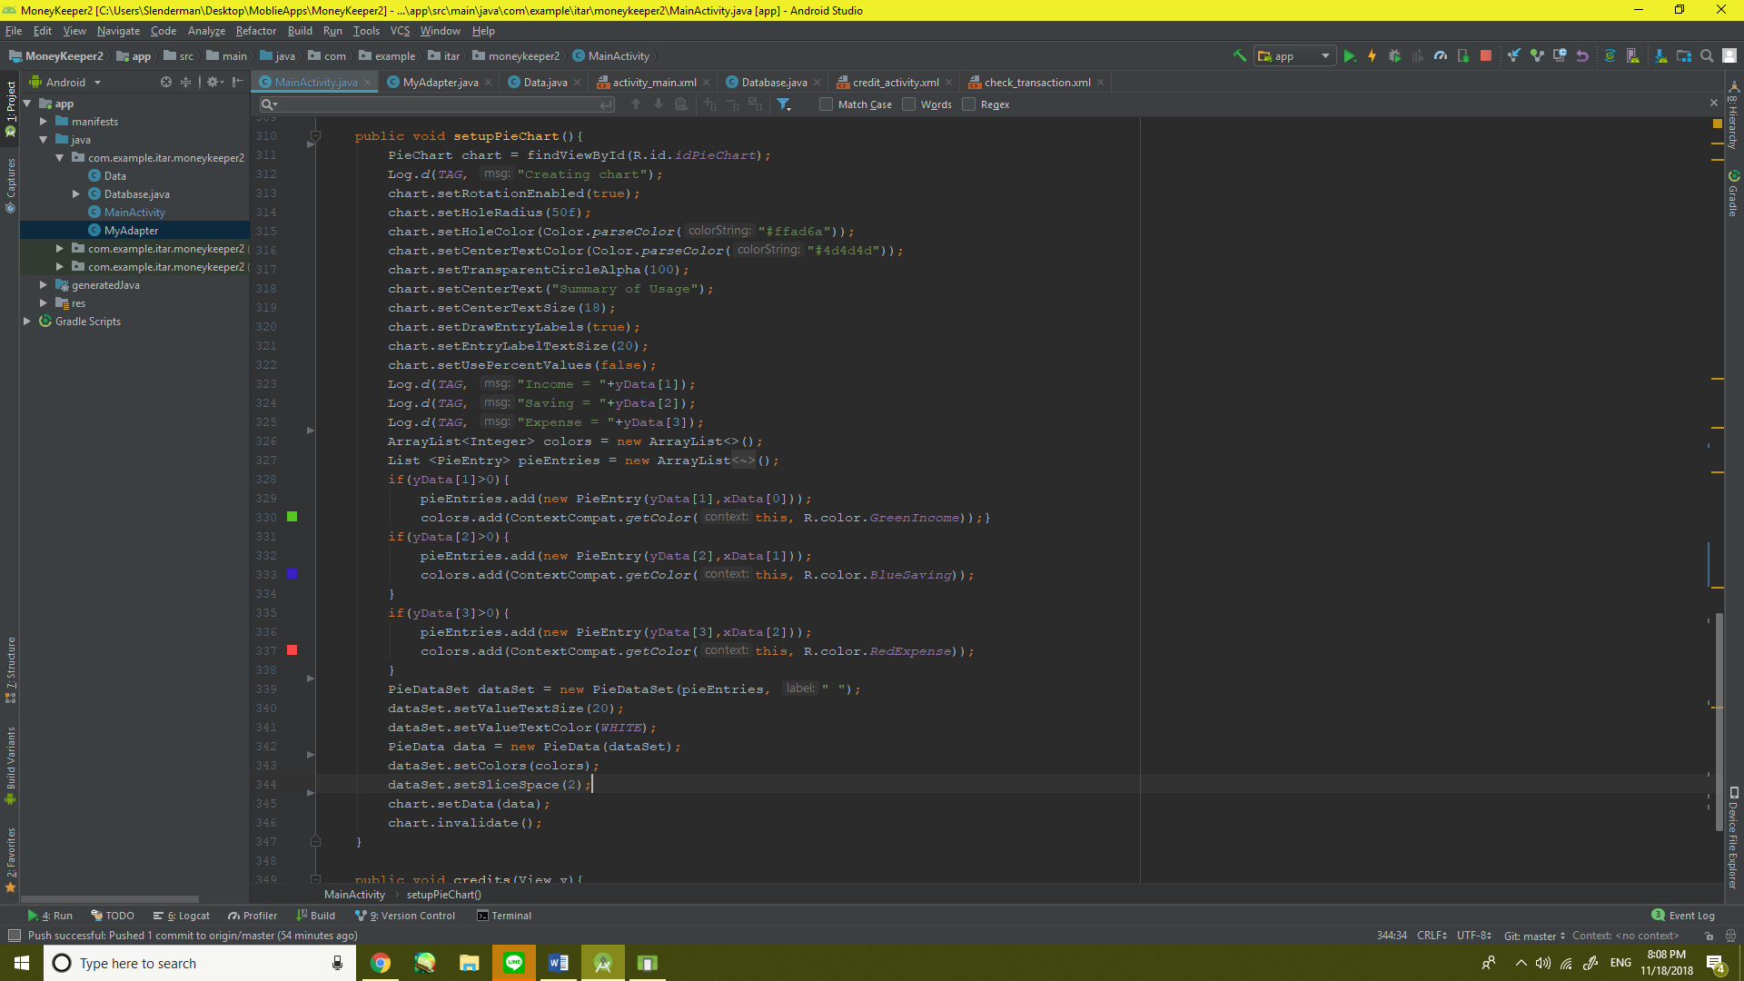

4.All Button Listeners

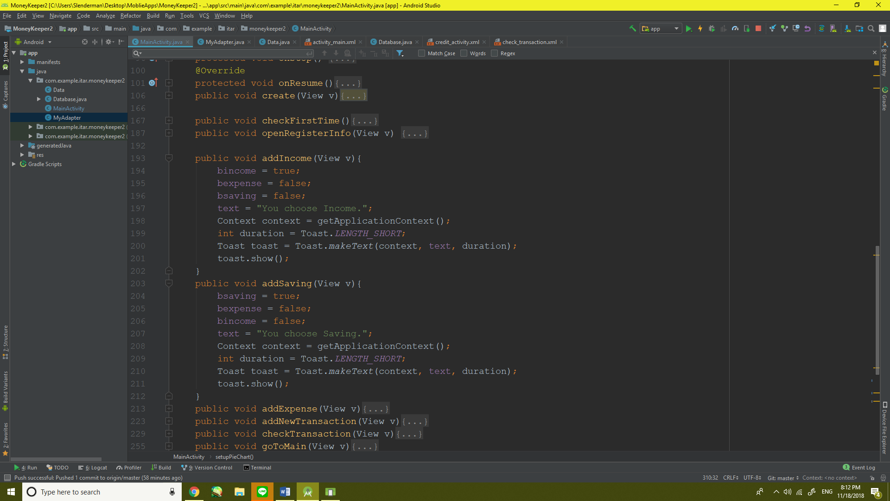



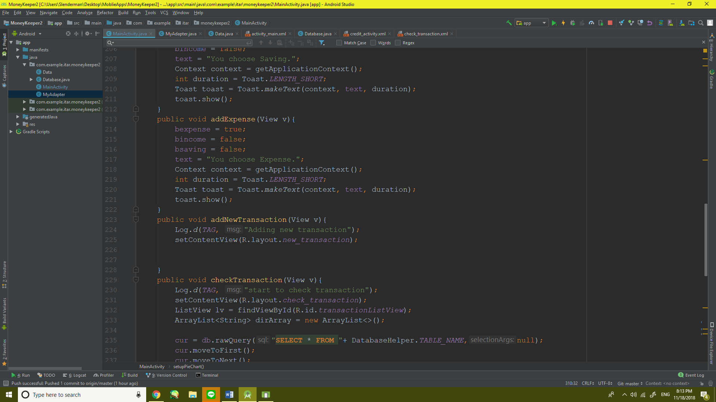



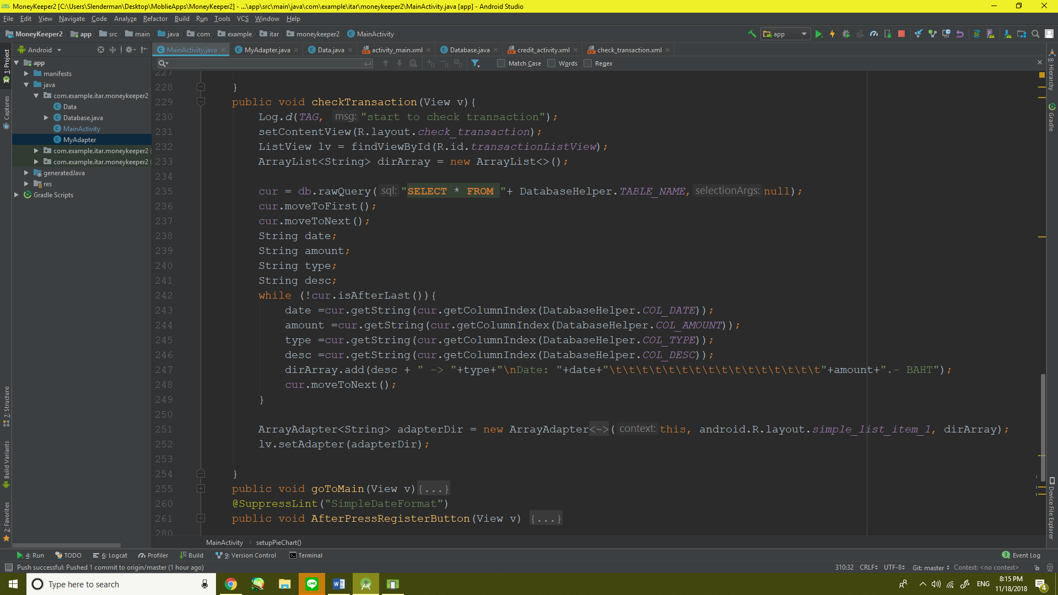

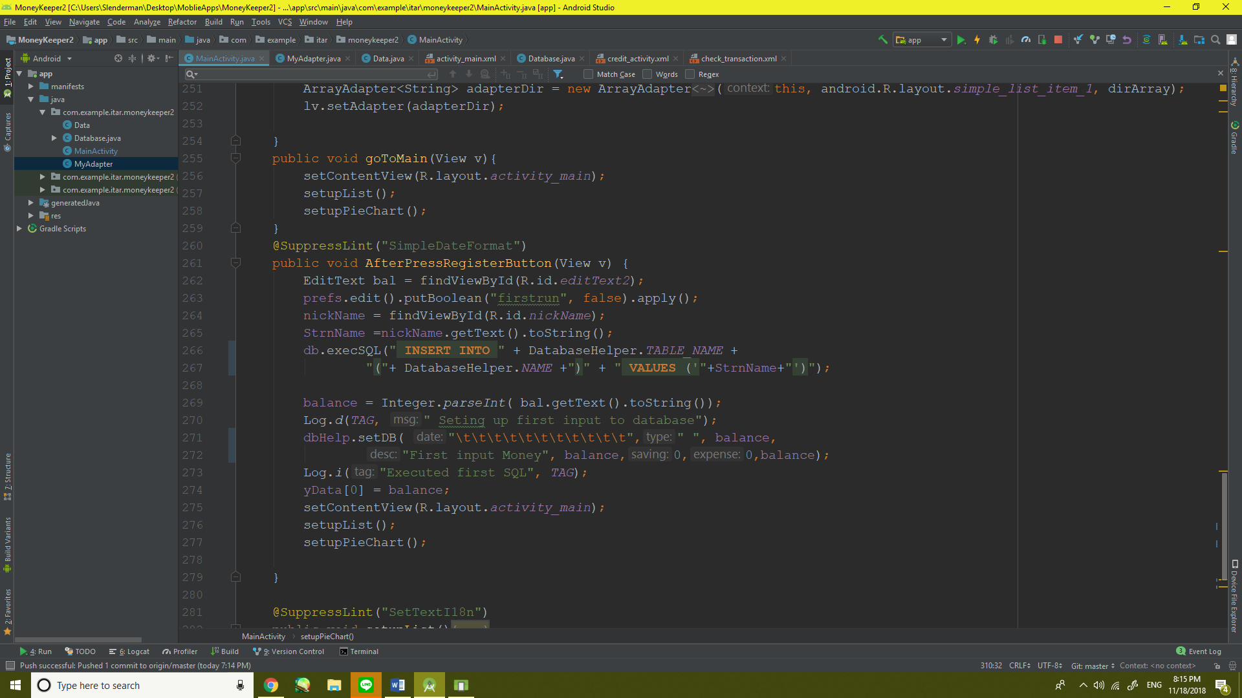



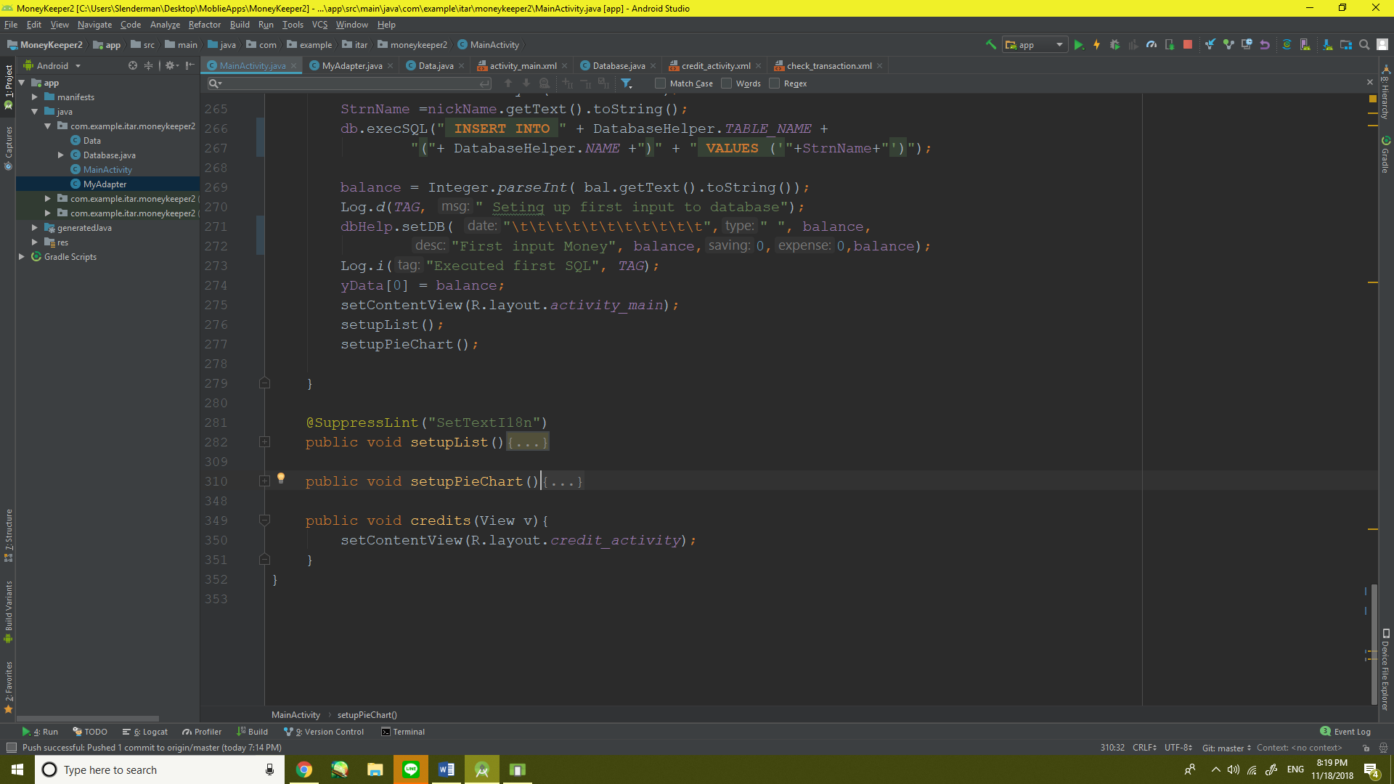

5. All methods override from AppCompatActivity

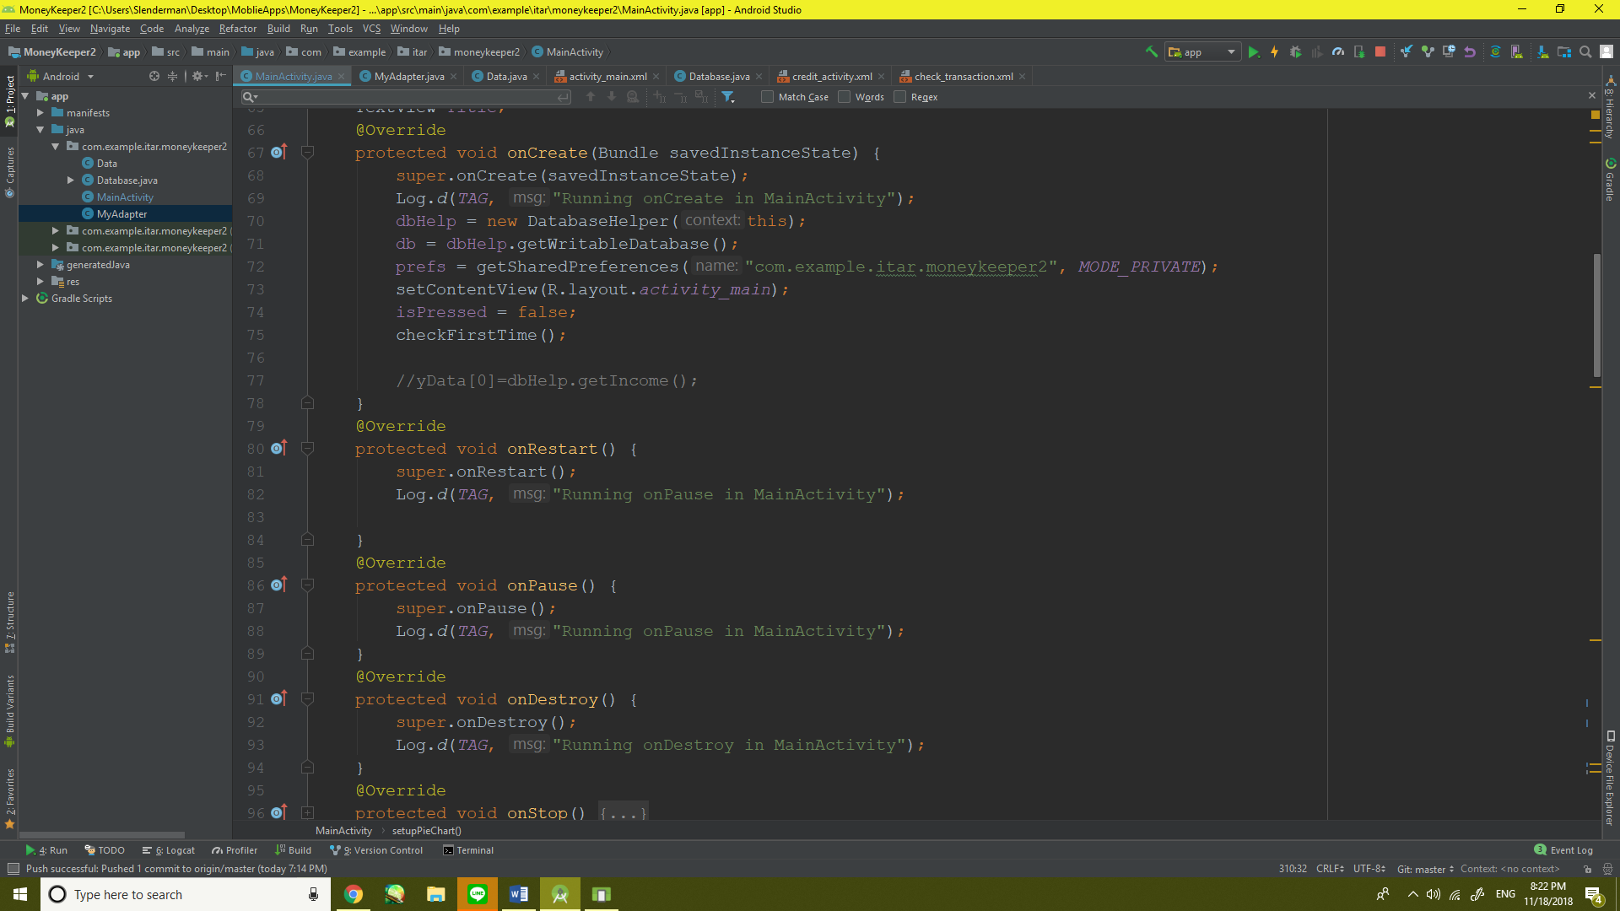







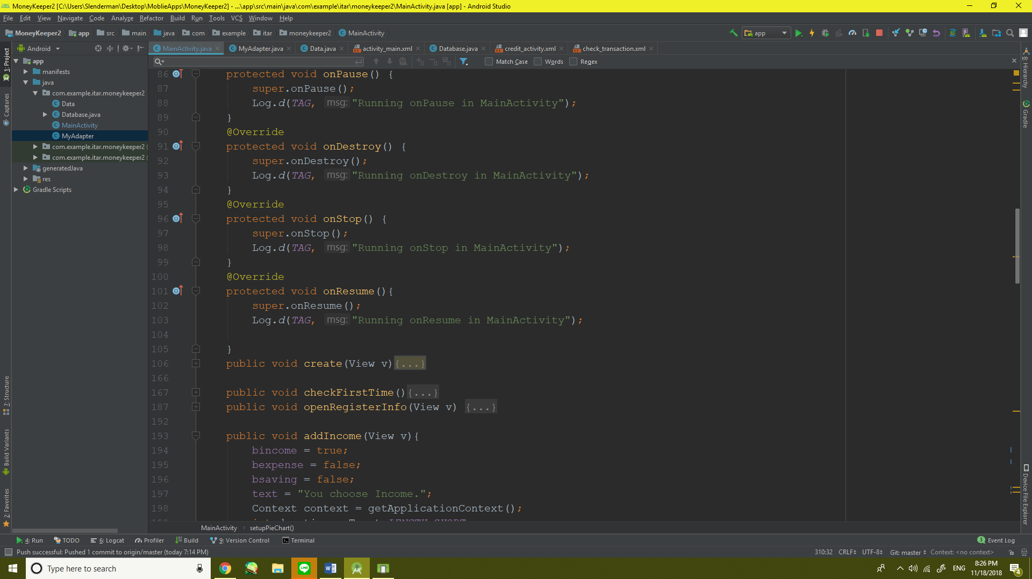



6.Methods Create is a button Listener that store data from editText to database

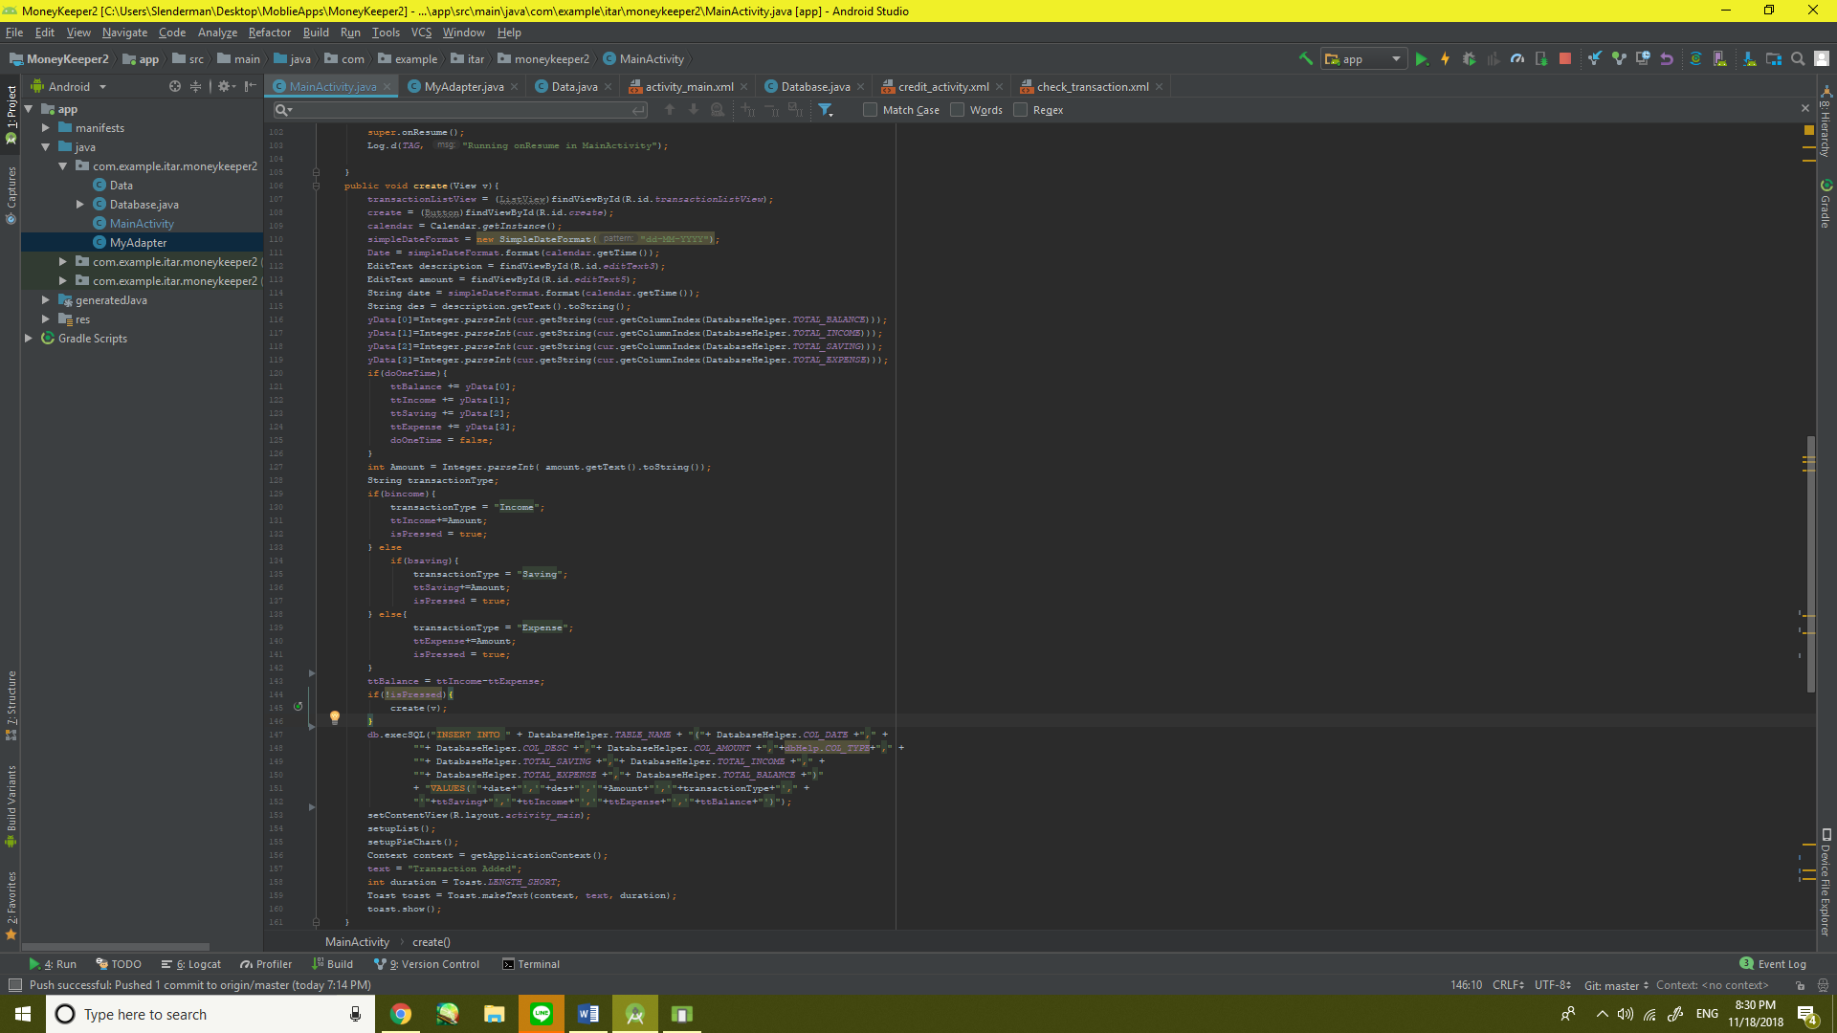

Gradle

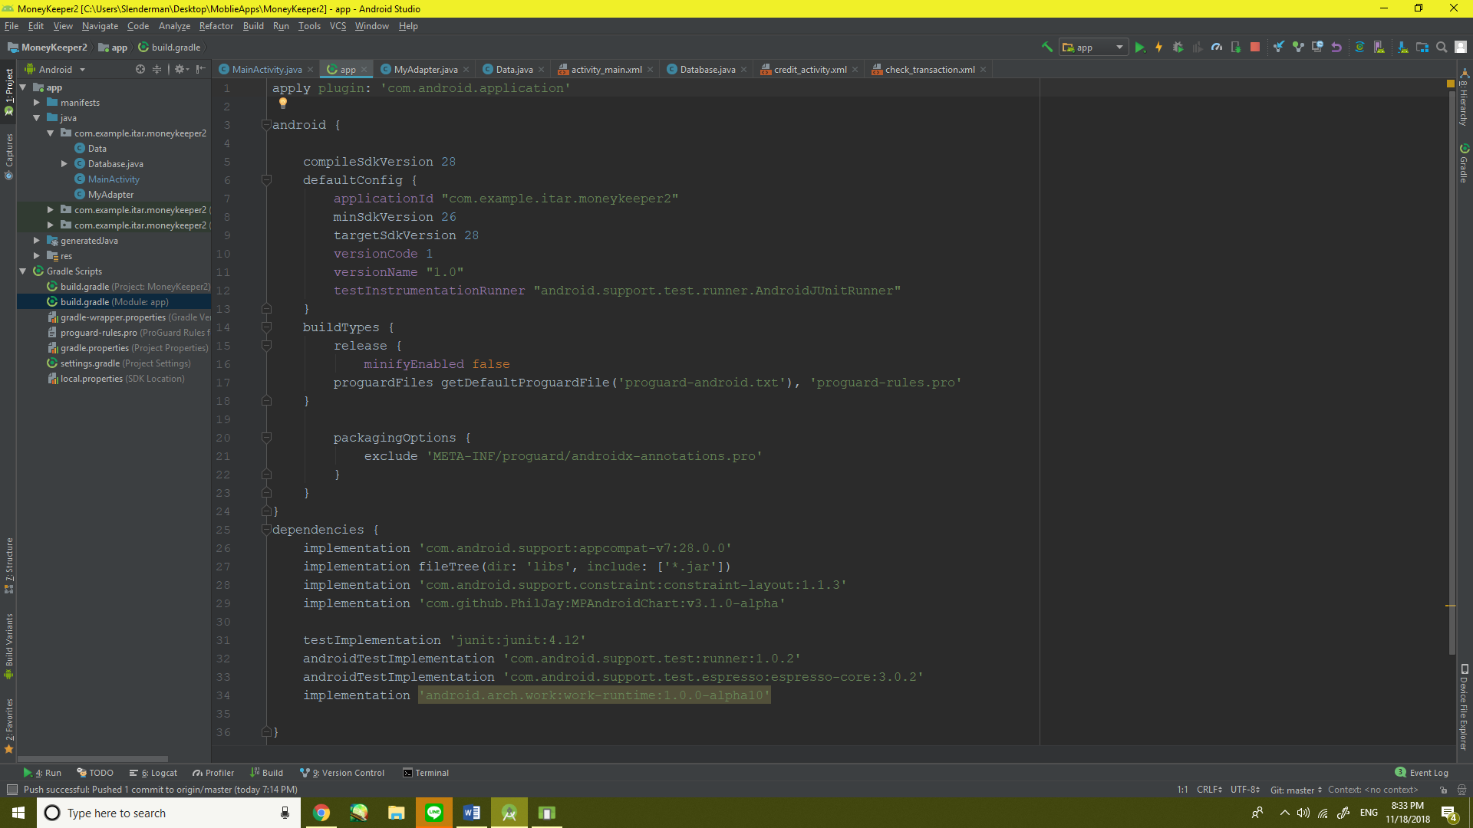

All XML Files

1) First Time

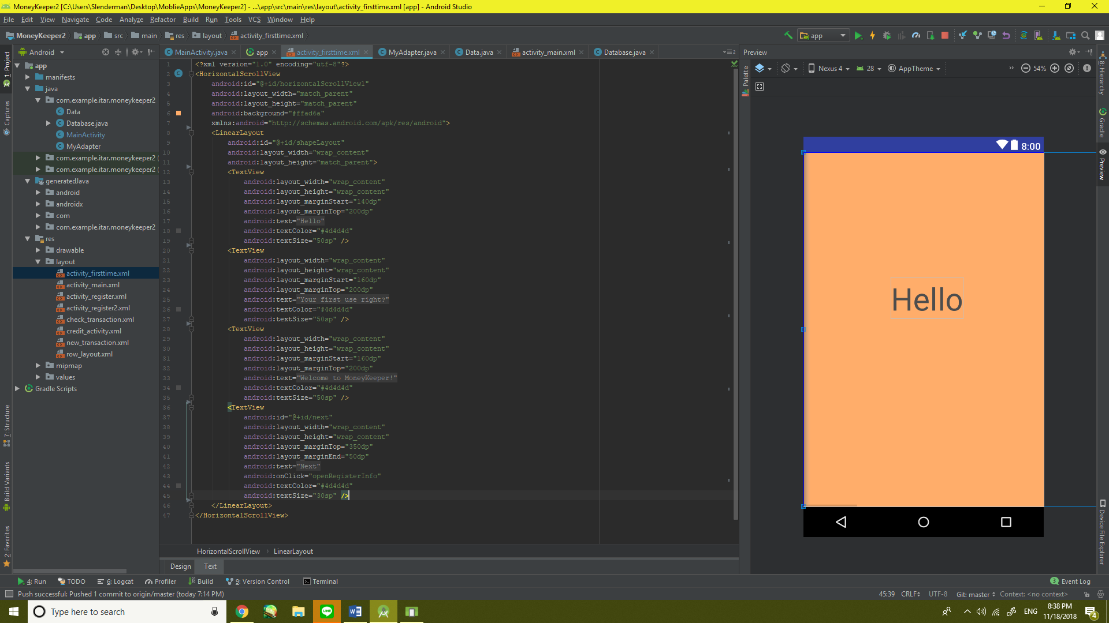

2) Main

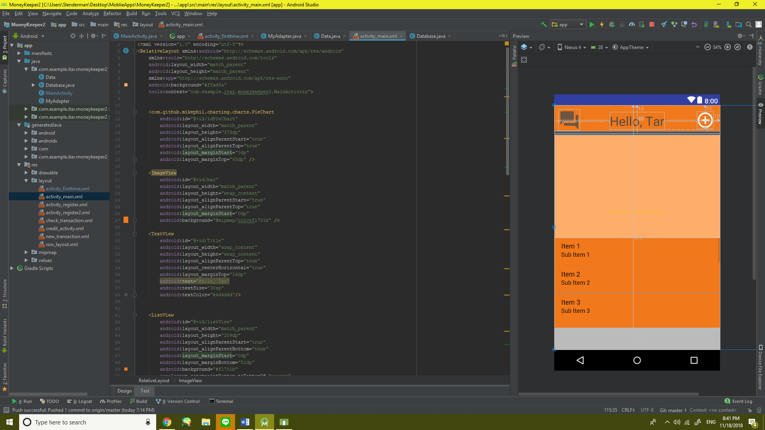 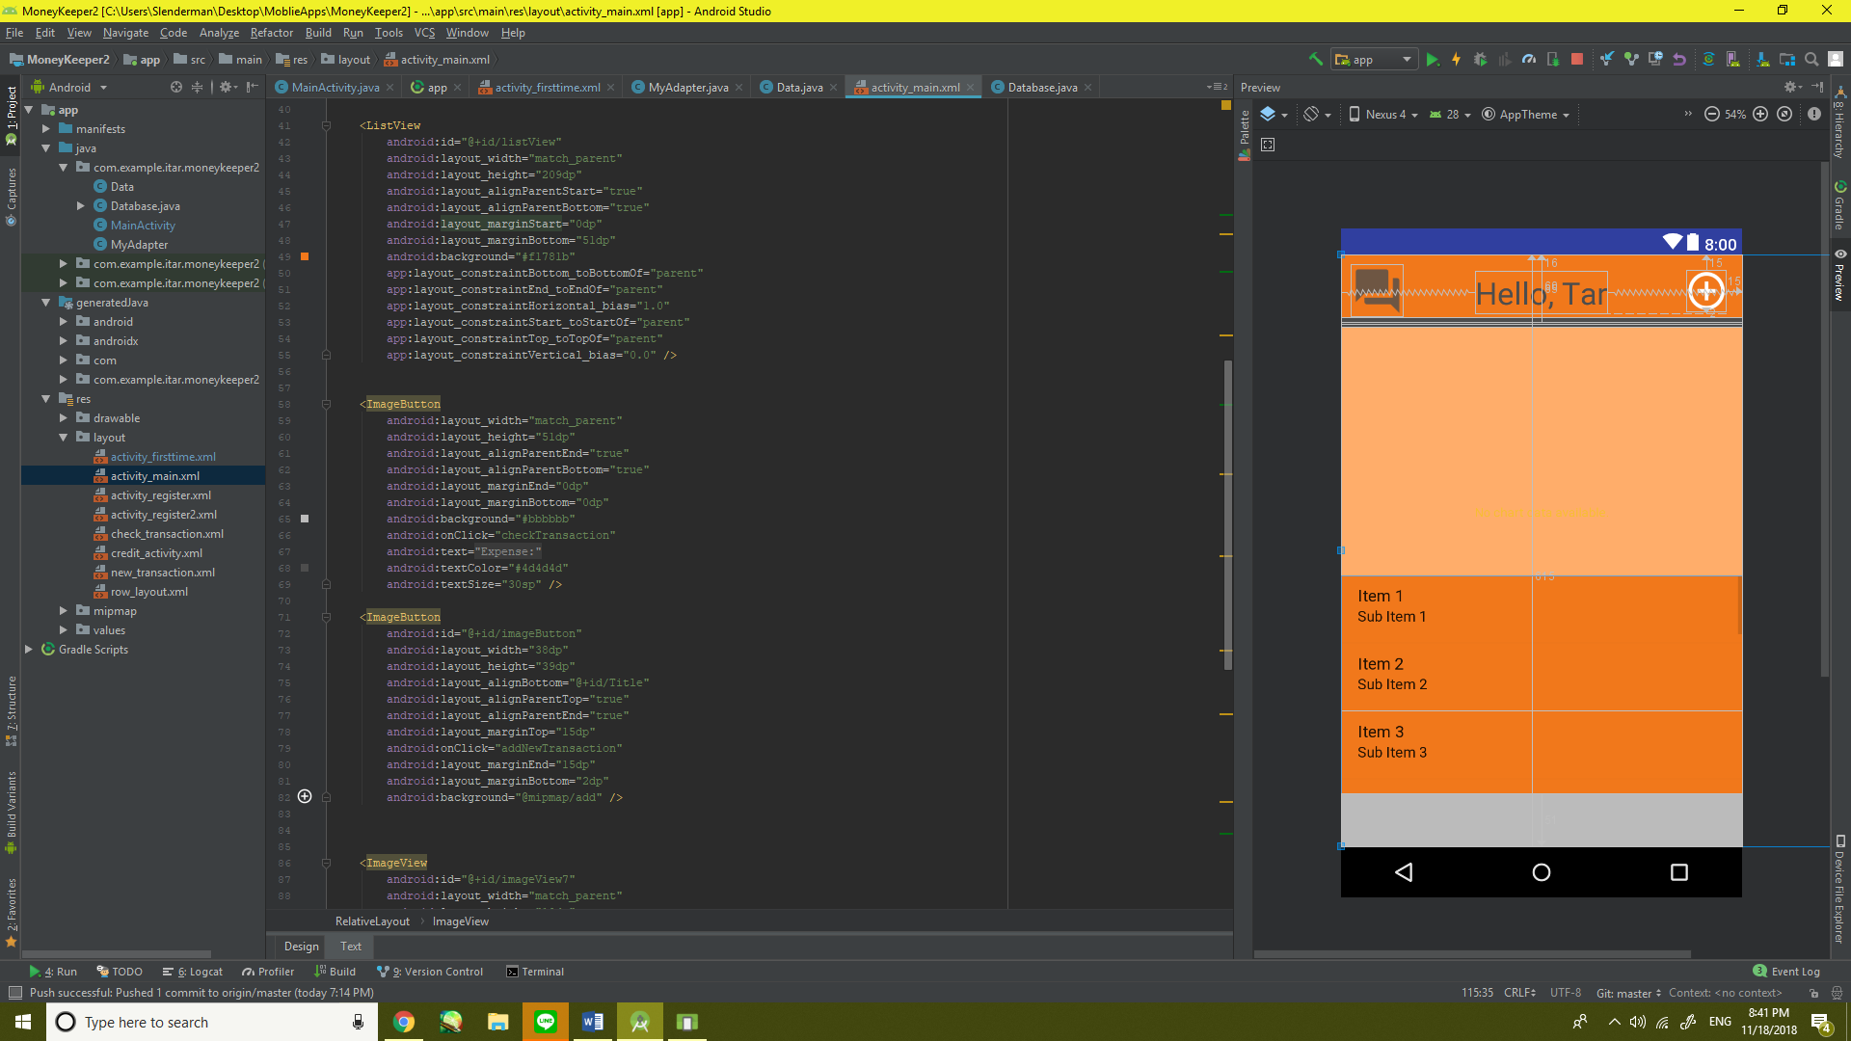

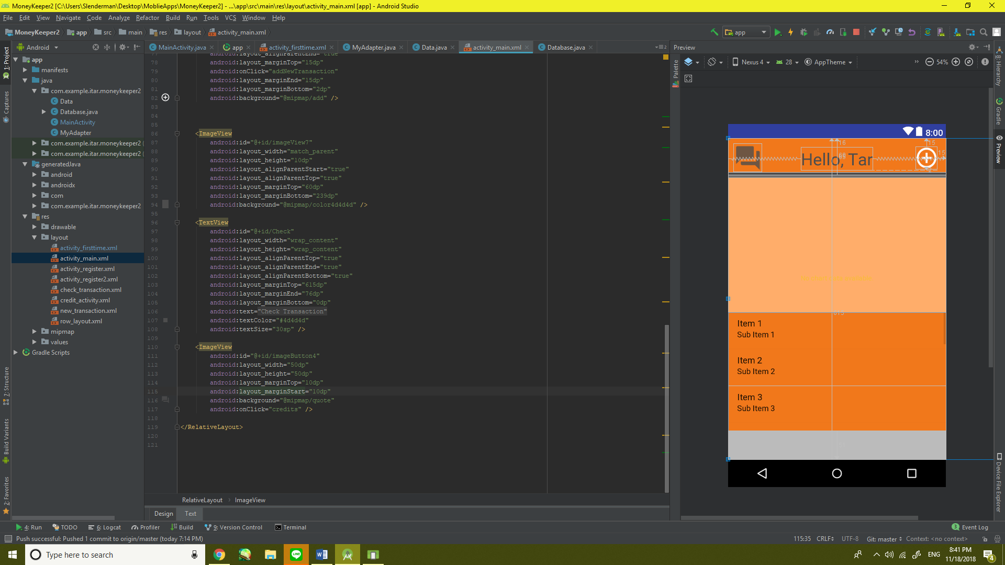

3) Register

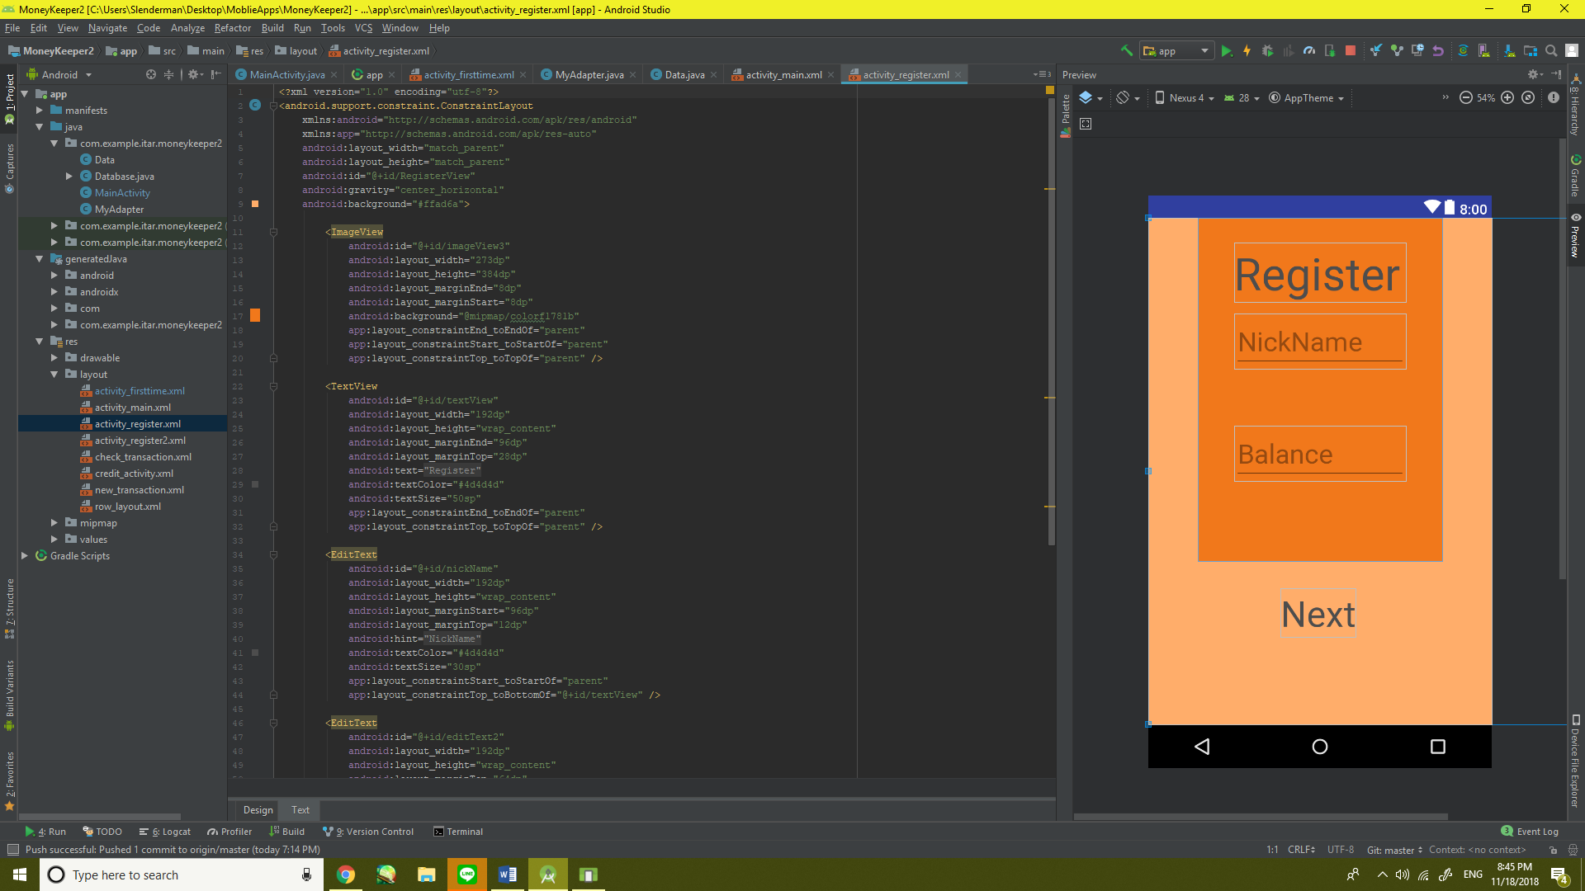 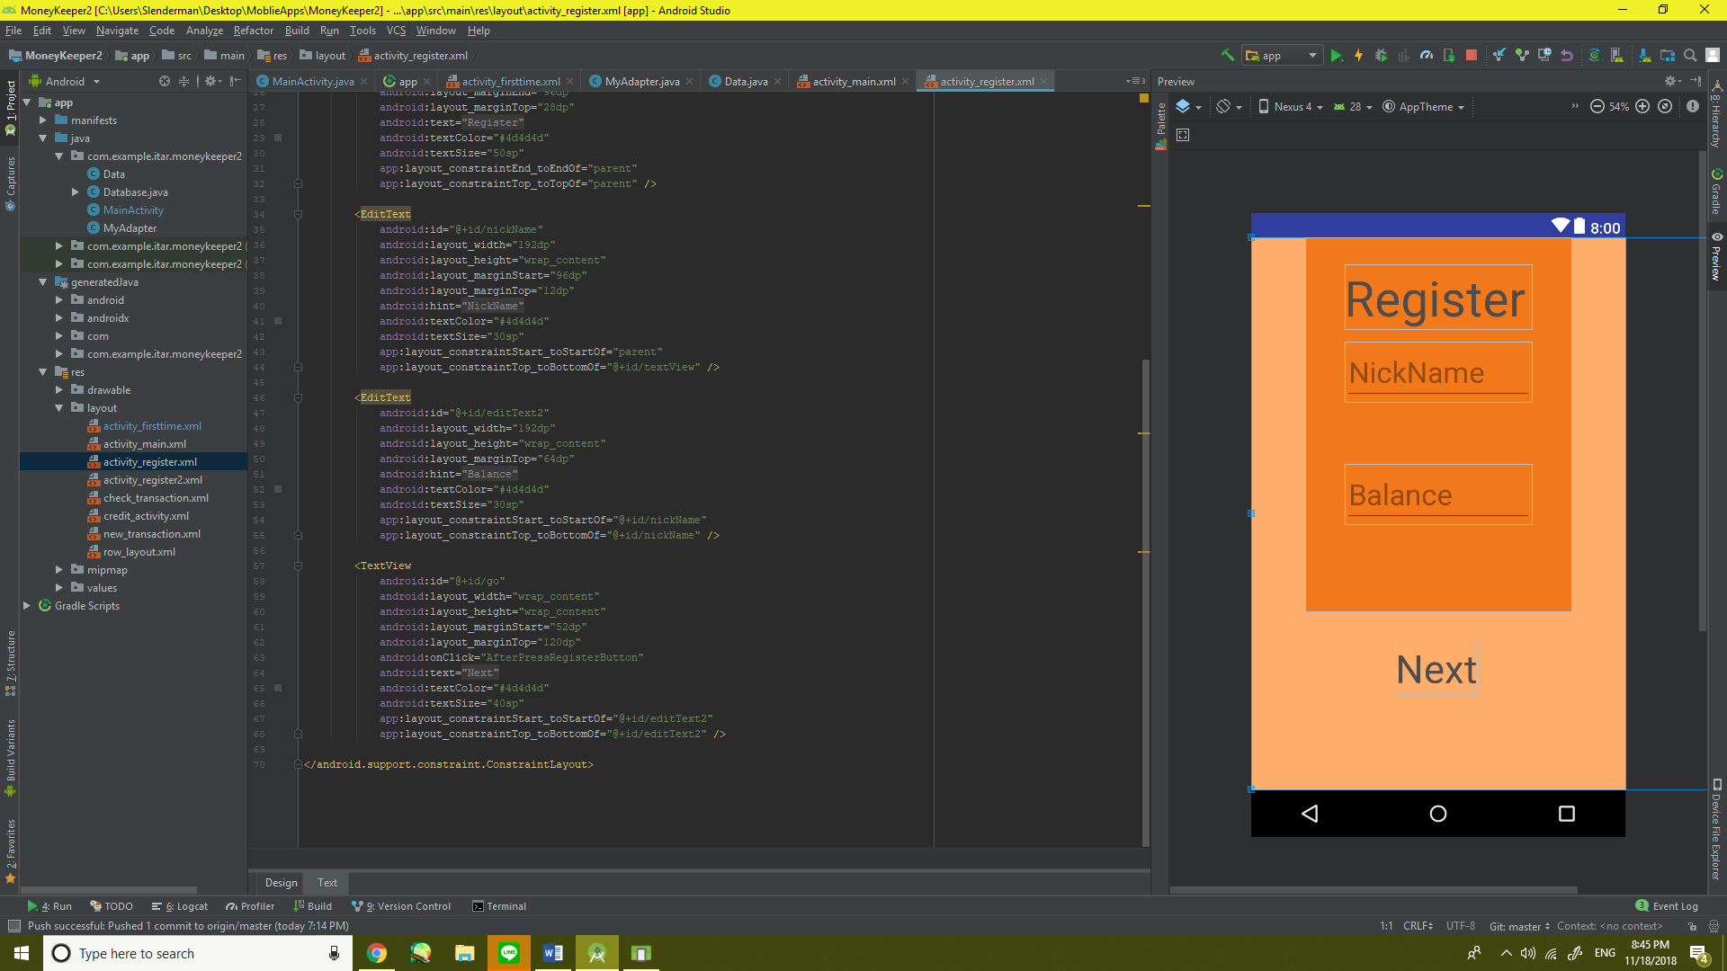

4) Check Transaction

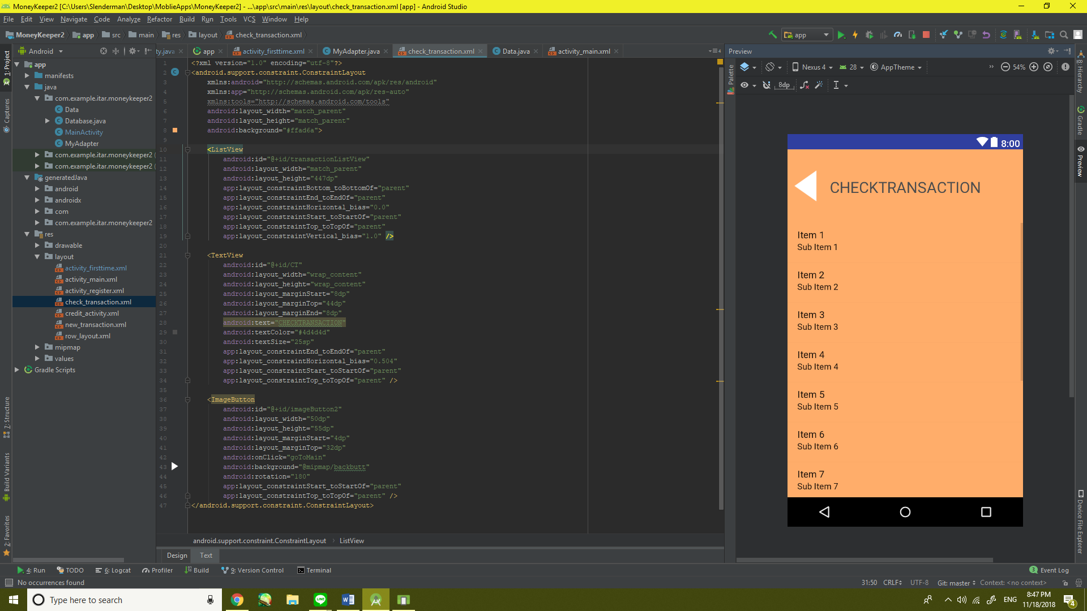

5) Credits

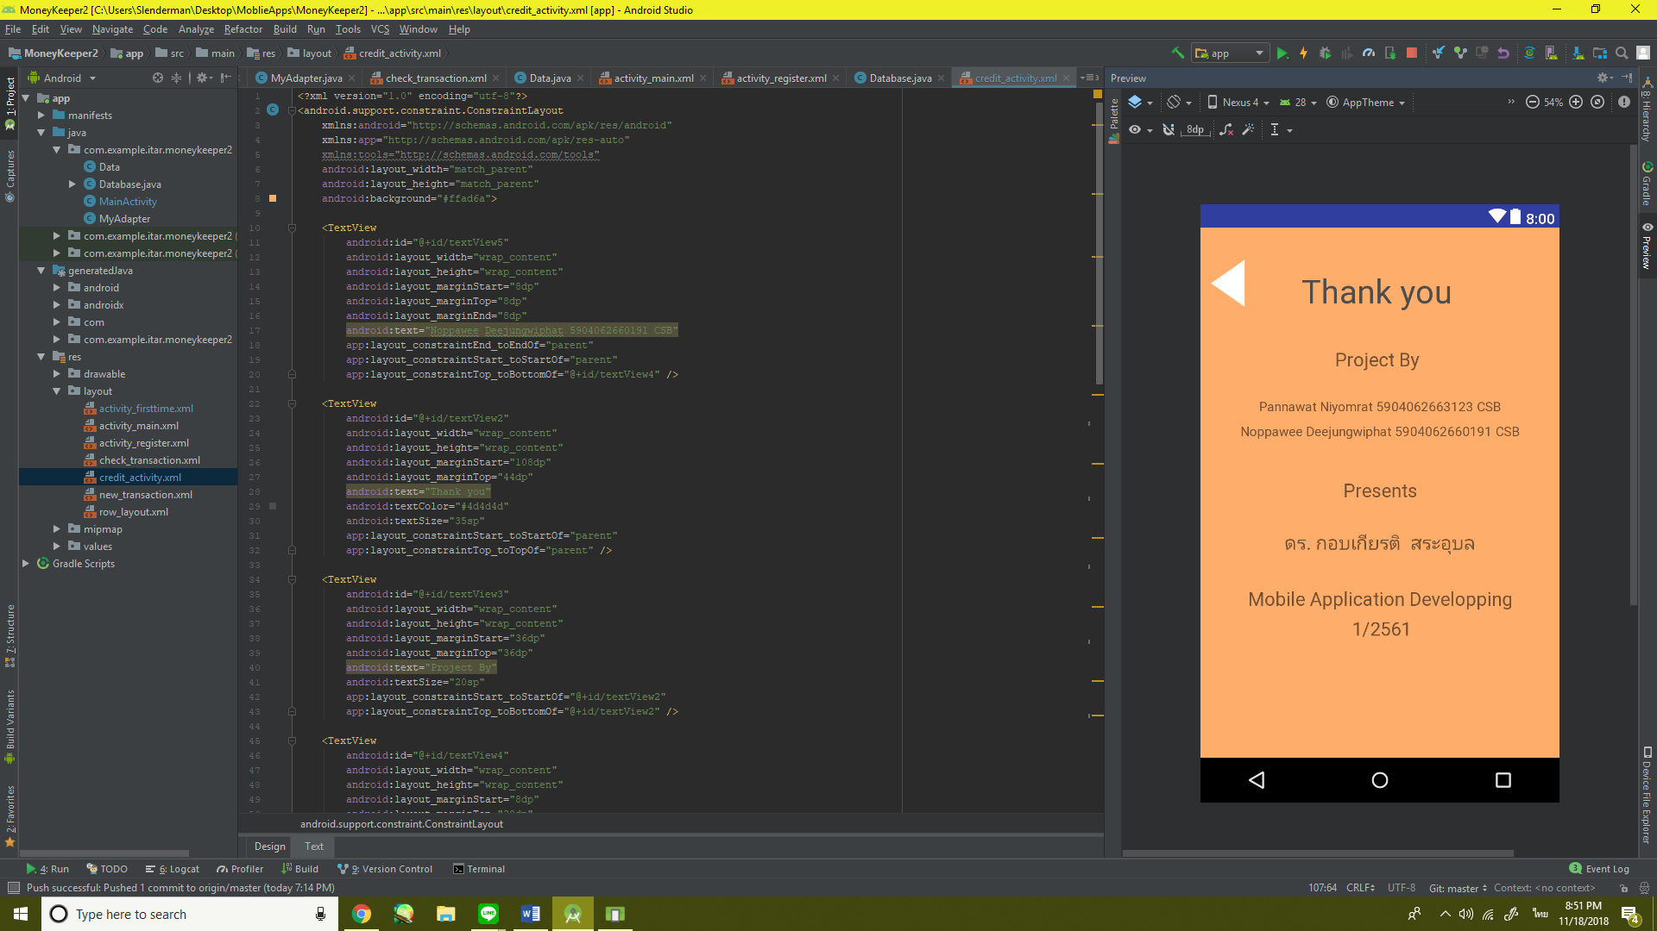 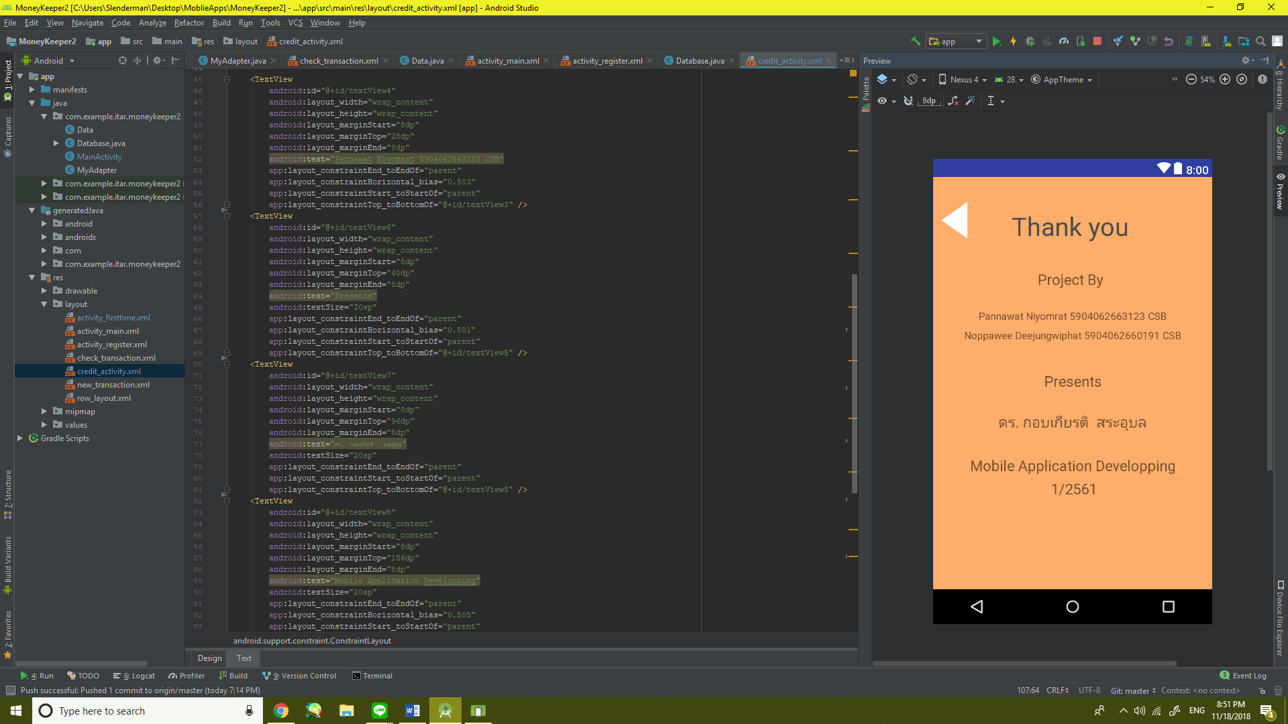

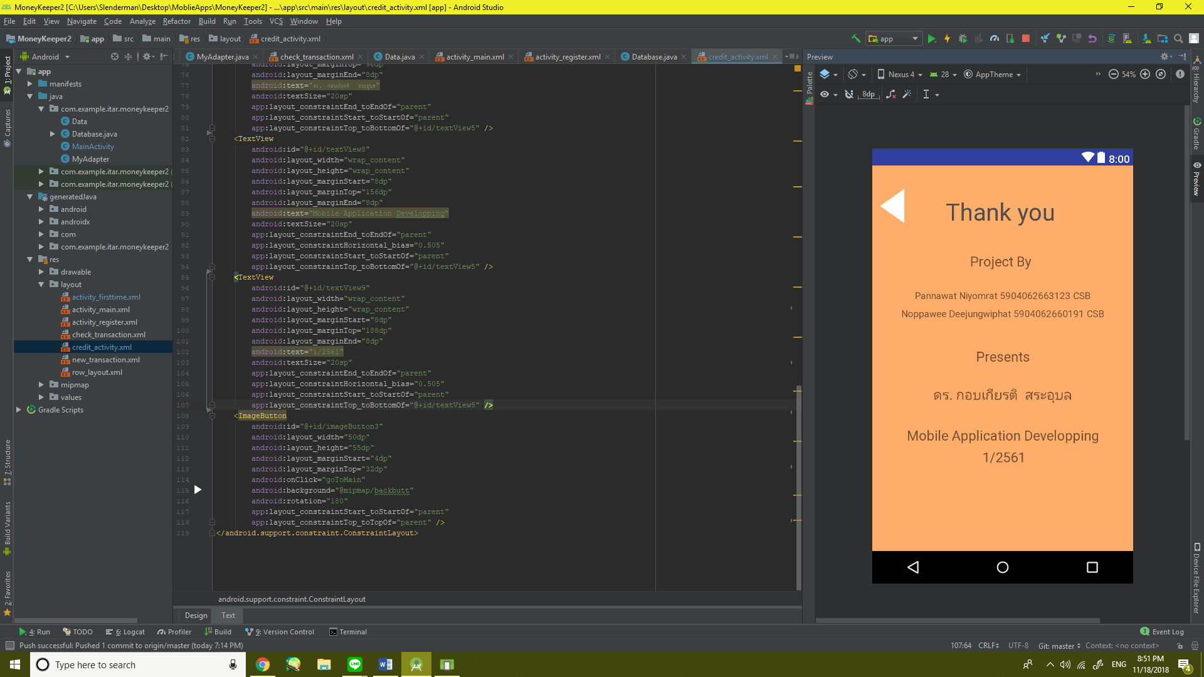

6) New Transaction

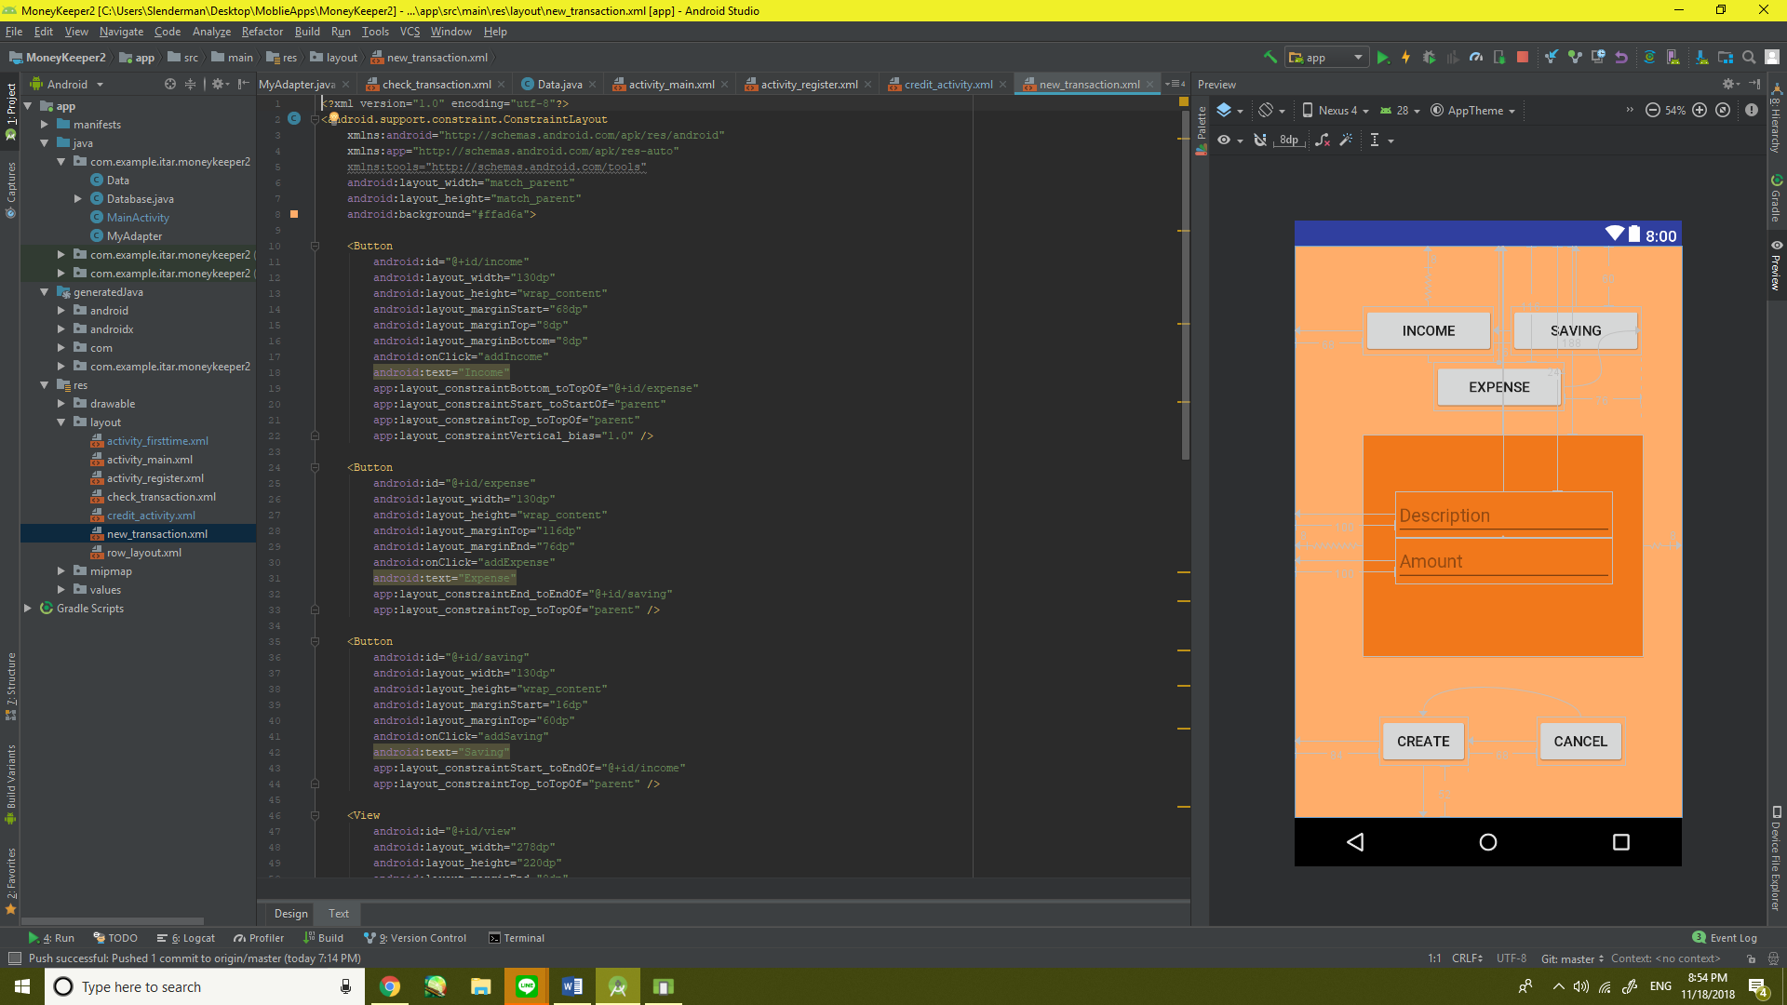 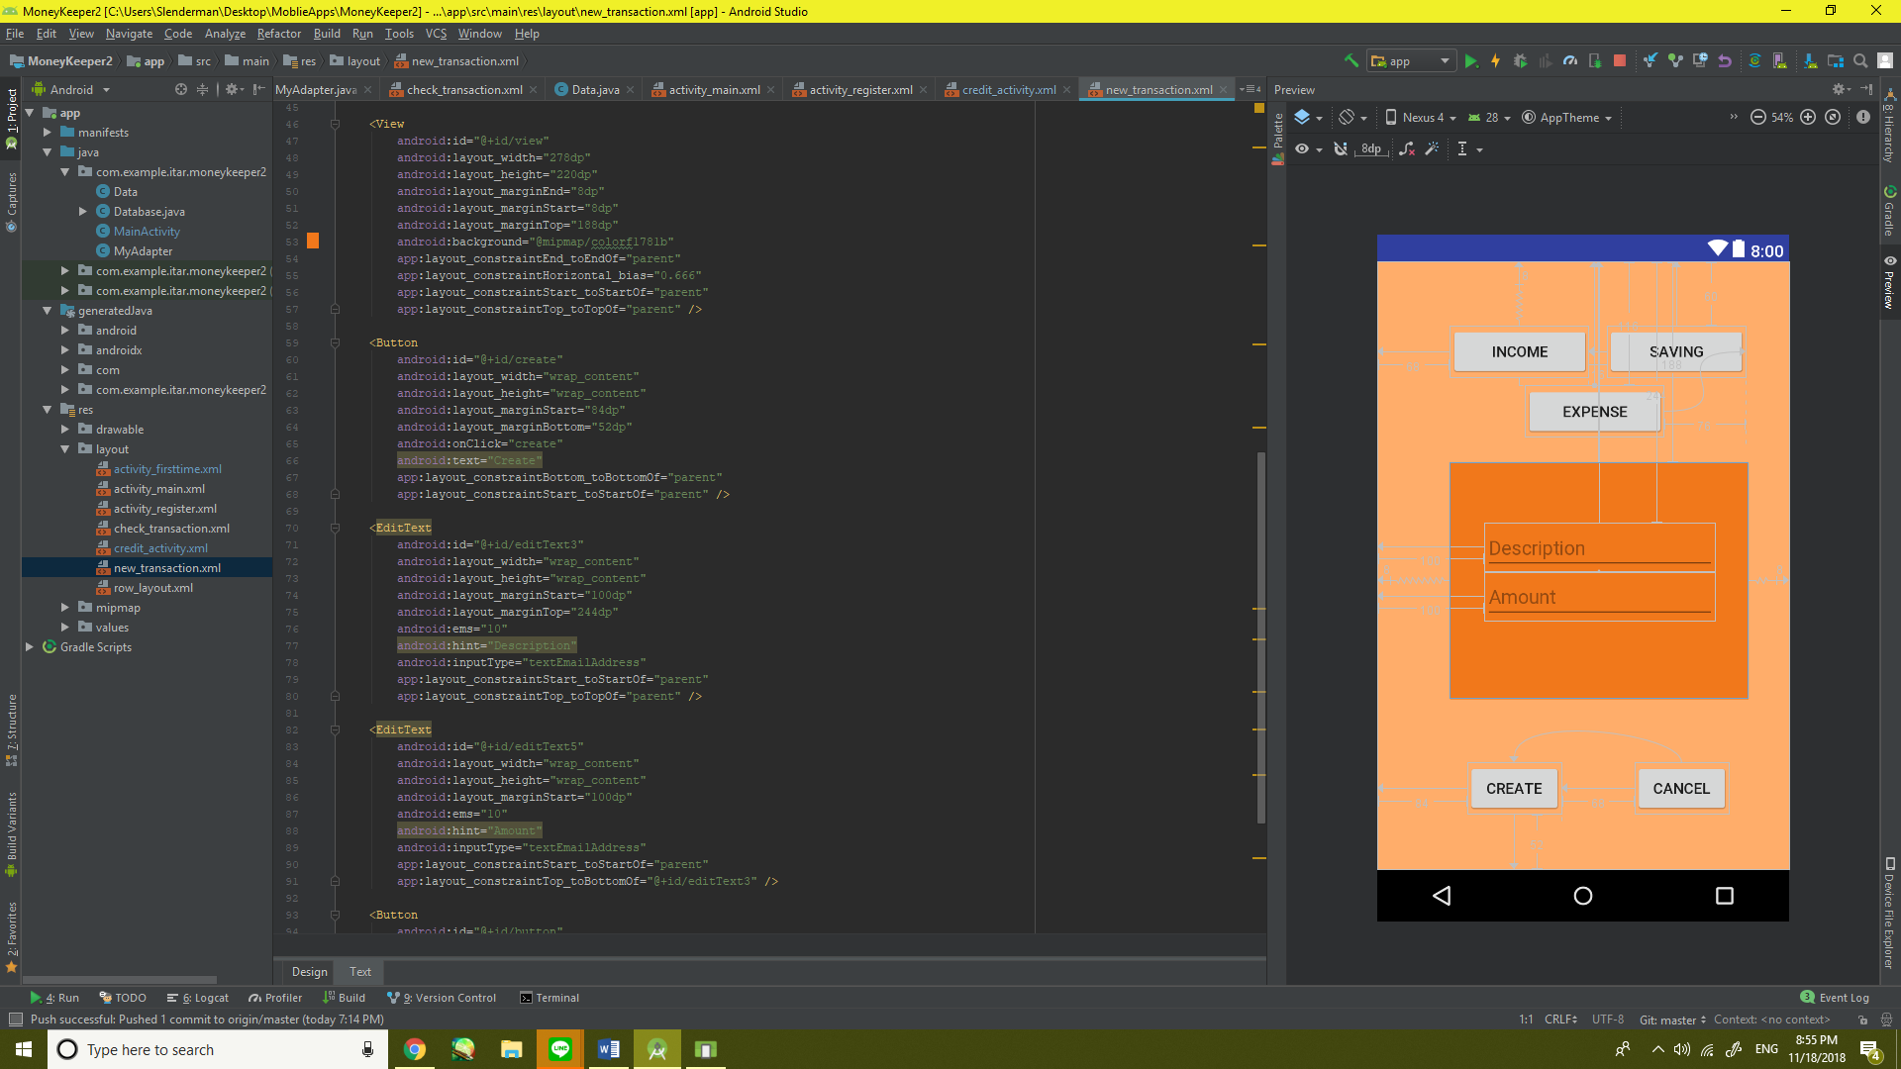

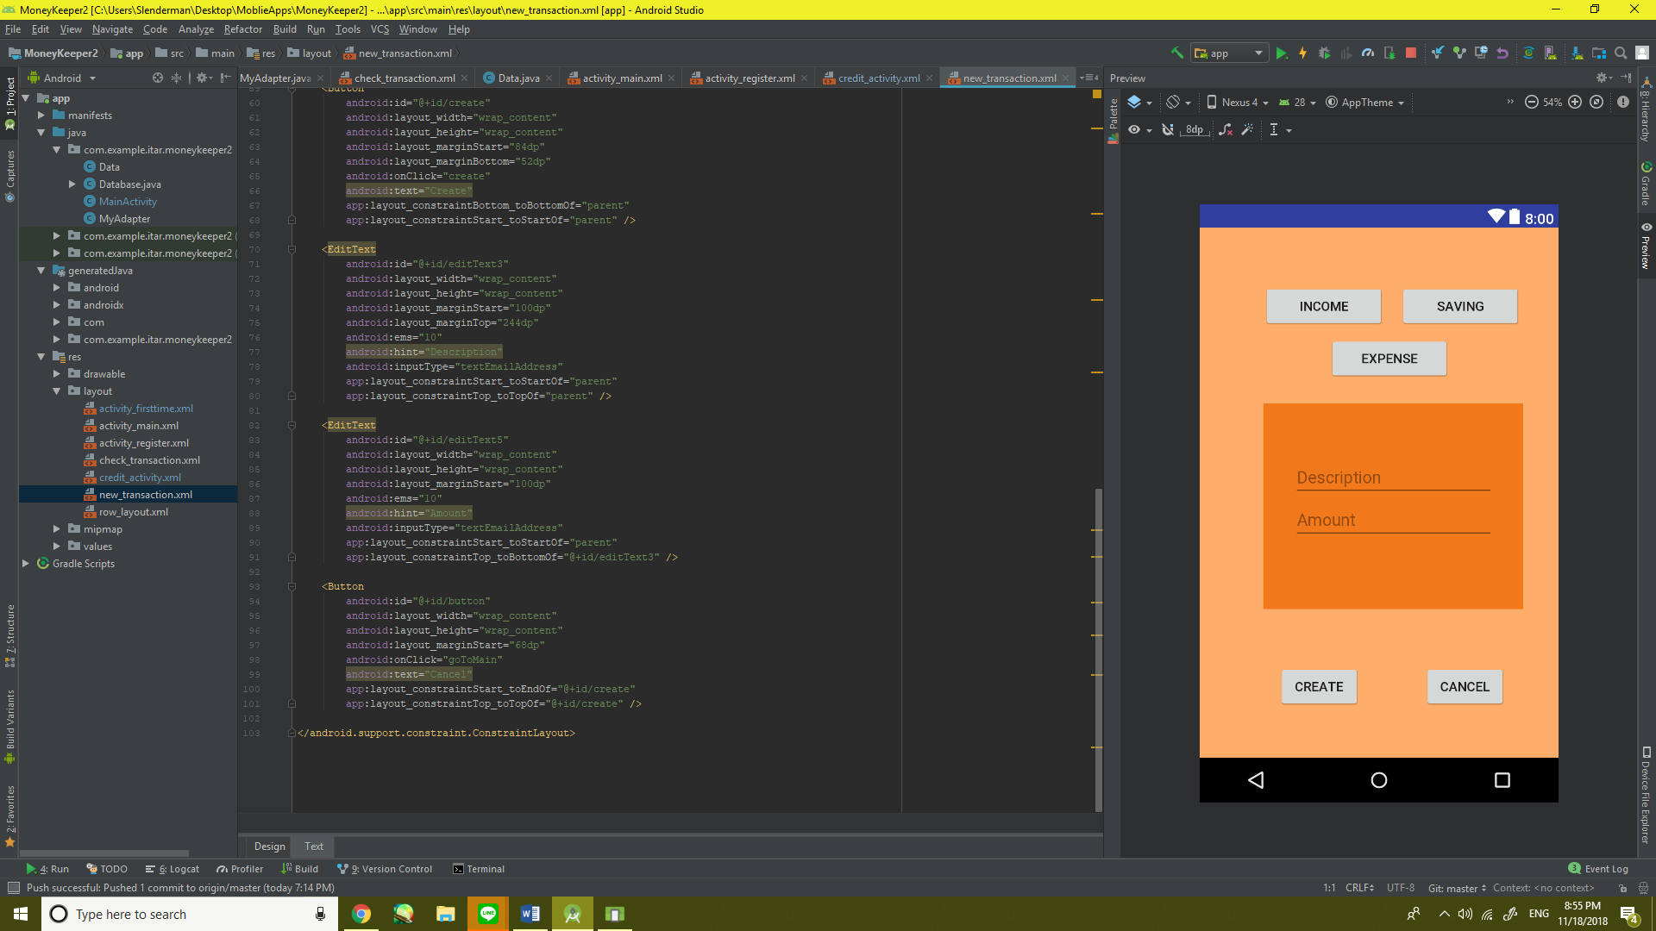

Bibliography

 Kobkiat Saraubon Ph.D.

www.github.com

www.stackoverflow.com

www.youtube.com/channel/UCoNZZLhPuuRteu02rh7bzsw

www.w3resource.com

www.devahoy.com

www.developer.android.com

www.geeksforgeeks.org